Dickson Mukimbiri, Daniyar Mirlanuly, Kemal Bektaş, Egide Tuyizere, Sevgi Ataş Elif Işılsu Çınar, Şimal Kara, Hakizamungu Eric, Berthile Urujeni
Türk Hava Kurumu Üniversitesi Ali Ruhşen ÇETE
Türk Hava Kurumu Üniversitesi Ankara

Research ınto hıgh-performance ducted propeller desıgn

Abstract
A High-Performance Ducted Propeller is an advanced propulsion configuration in which the rotor is enclosed within an aerodynamically optimized cylindrical duct. This design aims to increase propulsive efficiency by reducing tip vortex losses and improving control of the pressure distribution around the blades. By confining and guiding the airflow, the duct enhances thrust production, stabilizes the flow field, and reduces energy losses that typically occur at the blade tips in open propeller systems. A key advantage of the ducted configuration is its ability to provide superior low speed performance and higher static thrust, making it particularly valuable for applications such as vertical take-off and landing (VTOL) aircraft, unmanned aerial vehicles (UAVs), marine thrusters, and other propulsion systems requiring efficiency and precision at low forward velocities. The duct also contributes to significant noise reduction by shielding the rotor, improving operational safety and acoustic performance. Furthermore, the local flow field around the rotor–duct system can be tailored through geometric optimization, allowing them to achieve specific performance objectives such as minimizing drag, enhancing pressure recovery, or controlling flow separation. In overall, the integration of a duct around a propeller represents a critical design approach for modern high-efficiency propulsion systems. Its combined benefits— enhanced thrust, reduced losses, improved stability, and lower noise—make it a promising solution for next-generation aerospace applications.

Introductıon
The main objective of this study is to design a ducted propeller system with two coaxial fans. To achieve this main goal, the specific objectives of the study are as follows:
• To analyze aerodynamic characteristics of single and coaxial fan arrangements, focusing on lift generation, drag, torque balance, power generated, and interaction effects between the rotors. Use computational fluid dynamics (CFD) to analyze flow behavior in 2D and 3D, identify key loss regions, and validate aerodynamic performance under different angles of attack, to study pressure generation and viscous effects.
• To design an optimized duct geometry that enhances static thrust, reduces tip vortex losses, and minimizes noise emission
• To analyze the coaxial fan concept, focusing on rotor–rotor aerodynamic interaction, counter-rotation effects, and torque balance to improve overall efficiency and reduce swirl losses.
• To compare different methods of computation. By using different approaches, including numerical, analytical and experimental solutions.
Methods
Ducted propellers are a topic that has recently attracted considerable attention, [Cai, H. et al. 2022] conducted about “Numerical Prediction of Unsteady Aerodynamics of a Ducted Fan UAV”. Shows that a ducted configuration can improve thrust and reduce power consumption compared with unducted coaxial propellers in UAV applications. [Mattingly, Ohain, 2006]. “Elements of Propulsion, Gas Turbines and Rockets”. [Anderson, Cadou 1970]. “Fundamentals of Aerodynamics”, 7th Edition Mende hall, 1970], Theoretical Study of Ducted Fan Performance. A foundational study explaining how duct geometry and internal flow characteristics affect ducted fan/propeller thrust and performance. [Farokhi 2014] “Aircraft Propulsion” 2nd edition. [Zante,. 2015], Modern Design and Performance of Counter-Rotating Open Rotors. Discusses the aerodynamic basis of contra-rotating propellers and highlights how wake/swirl recovery can improve propulsive efficiency.
Conducted Research Activities
Ducted Propeller consists of several main parts: Duct (shroud), Twin Co-axial fan Connector

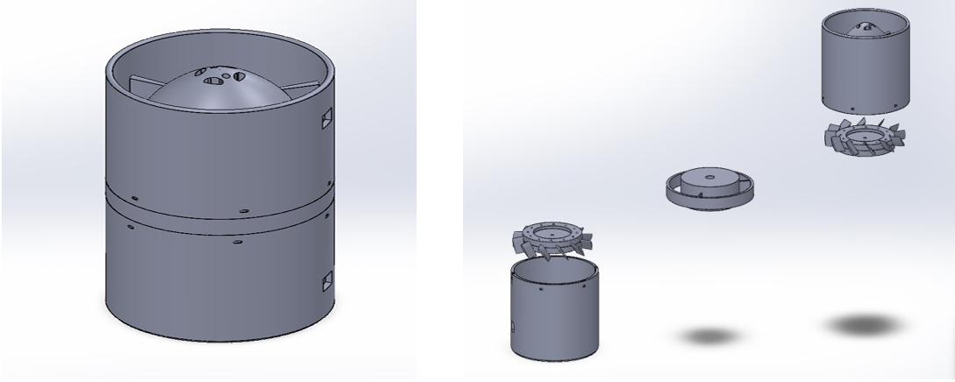
Figure-1: Exploded view of conceptual model

The fans have 12 blades. Each blade uses a NACA 4412 profile with a chord length of 30mm and blade span of 17.44 mm. Geometry of conceptual fan model is given Figur 1 and 2.

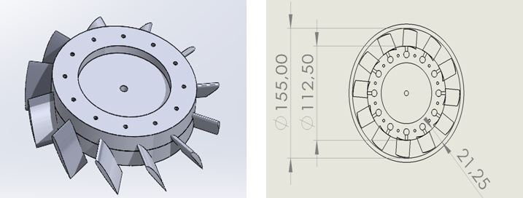

Figure-2: Fan dimensions
Single rotor 2-D CFD Analysis
The first step in turbomachinery design is a two-dimensional analysis along a representative ‘mean-line’, a simplified model of the true three-dimensional flow. We consider an axisymmetric stream surface at an intermediate position between hub and tip, with stations at the inlet and exit of each blade row. To compute aerodynamic performance (Lift, Drag, Torque and Power) of a ducted propeller the momentum(actuator-disc) approach using outlet velocities from ANSYS Fluent has been applied.
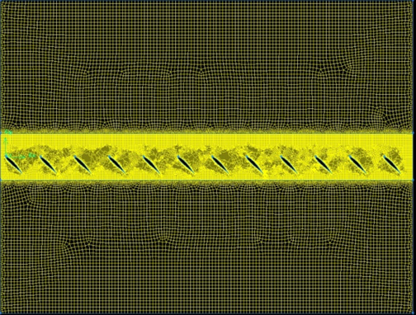

Figure-3: Mesh created in GAMBIT by using mean-line approximation

Mesh consists of several major parts: Airfoil geometry, Airfoil boundary layer mesh, Applied periodicity, Rotor and stator mesh.

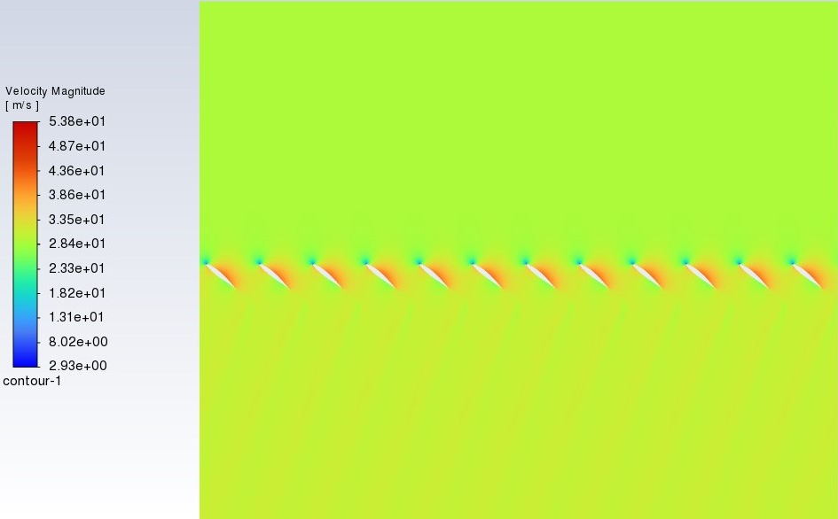

Figure-4: 2D ducted propeller reusult; velocity contours.

Mesh was analyzed directly in ANSYS Fluent to receive CFD solutions. From solutions we will get most important properties: Lift, Drag, Torque and Power
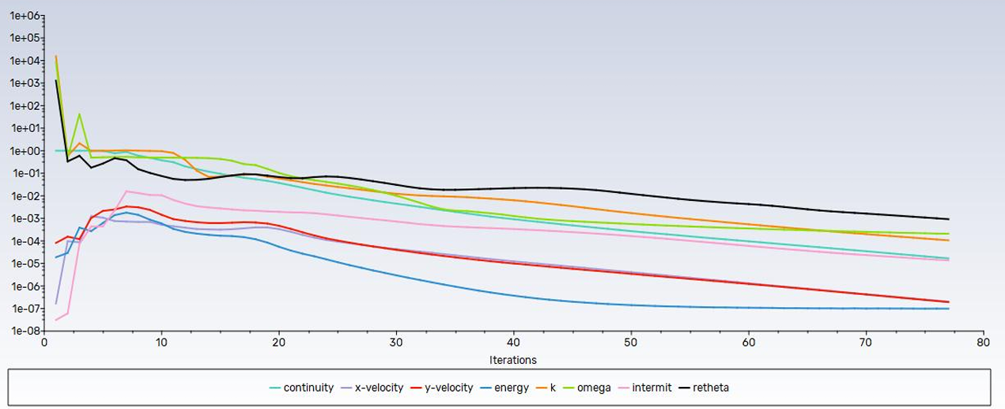

Figure-5: Residuals for 20° Angle of Attack

The convergence of the residuals (Figure-5) generally shows that performance is stable and accurate.

Results of 2-D Analysis
While calculating Force ANSYS Fluent approximate span as 1 meter which is larger than real distance of blade span, further computations will consider this fact. With the results obtained from ANSYS Fluent momentum(actuator-disc) approach used to calculate forces:

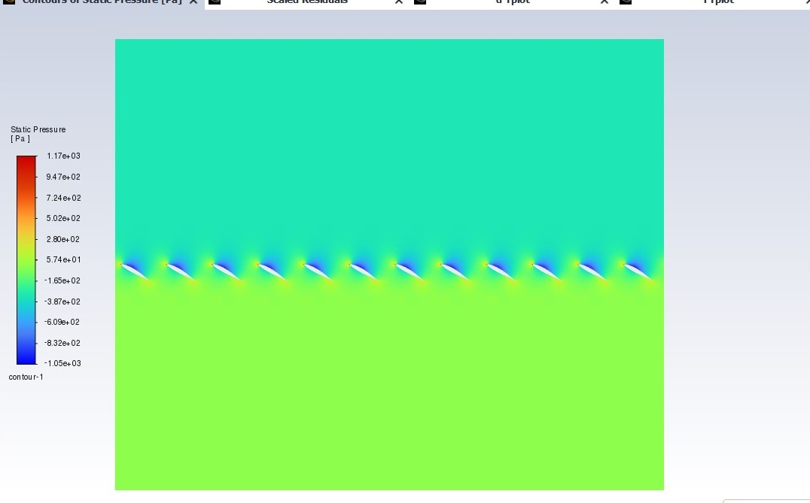

Figure-6: Contours of Static Pressure for 30° Angle of Attack

Table-1: Force result for 30° Angle of Attack

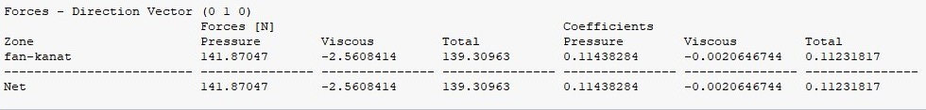

Table-2: Outlet Velocity magnitude result for 30° Angle of Attack
Momentum approach
$$L=ρAV_{out}^{2}=ρπ\left(R^{2}-r^{2}\right)V_{out}^{2}=1.225\frac{kg}{m^{3}}×π×\left({0.0775}^{2}m-{0.05625}^{2}m\right)×{23.646}^{2}\frac{m}{s}=6.1N$$
$D=F_{viscous}×b_{blade \operatorname{span}{}}=2.56\frac{N}{m}×0.01744m=0.0446N$
$$T=D×x_{center of pressure}=0.0446N×0.0678125m=3.02×{10}^{-3}N∙m$$
$$P=Tω=T\frac{V_{inlet}}{x_{center of pressure}}=3.02×{10}^{-3}N∙m×\frac{45\frac{m}{s}}{0.0678125m}=2.007W$$
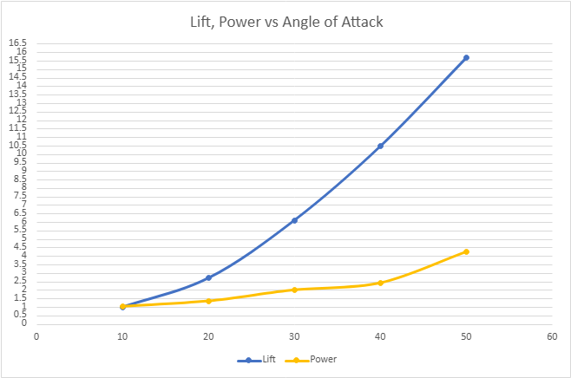
Figure-9: Lift and Power plots
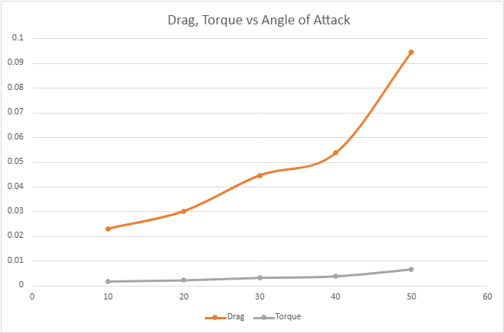
Figure-10: Drag and Torque plots

Single rotor 3-D CFD Analysis
This part represents the results of three-dimensional (3D) numerical analyses performed using ANSYS CFX and ANSYS Fluent. The main objective of the study is to investigate the flow characteristics and related physical quantities of the defined geometry through computational fluid dynamics methods and to evaluate the results comparatively.
The three-dimensional geometry used in this study represents a single blade passage of a fan consisting of a total of 12 blades distributed circumferentially. The analyzed section corresponds to one blade located on a 30-degree arc segment, allowing the flow behavior to be investigated by taking advantage of the geometric periodicity of the fan. The fan blade section has a chord length of 30 mm, while the airfoil length along the flow direction is 17.44 mm. The horizontal projection of the corresponding arc segment is 50 mm. This modeling approach reduces computational cost while preserving the essential physical characteristics of the full configuration, and the computational domain was constructed to accurately capture the curvature and spatial orientation of the blade channel within the fan casing.
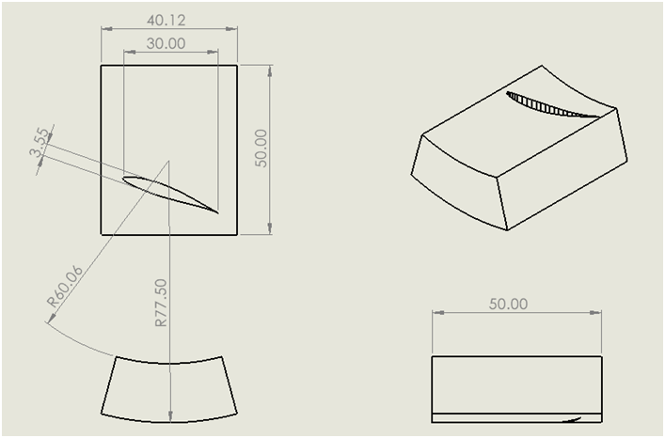

Figure-11: Dimensions of the arc segment

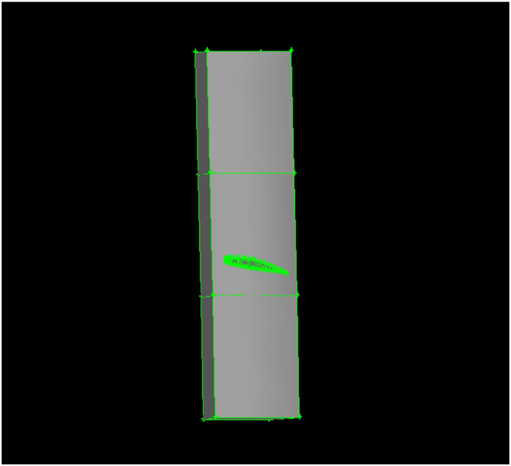

Figure-12: Complete Static and Rotary arc segment

Meshing
A high-resolution computational mesh (Figure-13, Figure-14) was generated for the analysis, consisting of approximately 2 million cells. The mesh was refined in regions of expected high flow gradients, particularly around the blade surfaces, near-wall regions, and interface zones, while maintaining a structured and smooth distribution in the upstream and downstream static sections. This detailed mesh configuration was designed to accurately capture the complex flow physics and ensure numerical stability and solution accuracy throughout the computational domain.
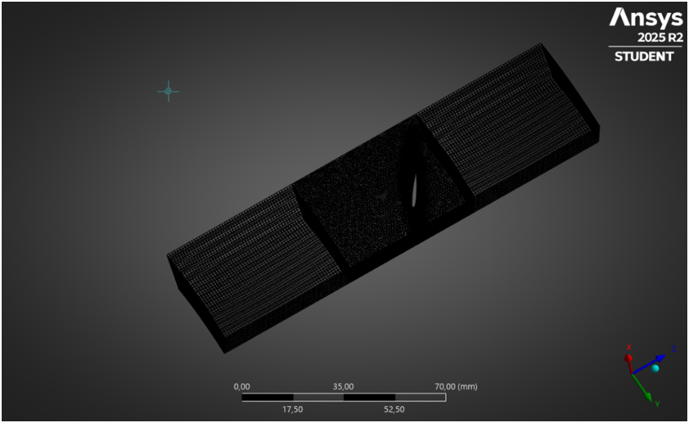

Figure-13 Mesh view of 3D CFD study for single rotor.

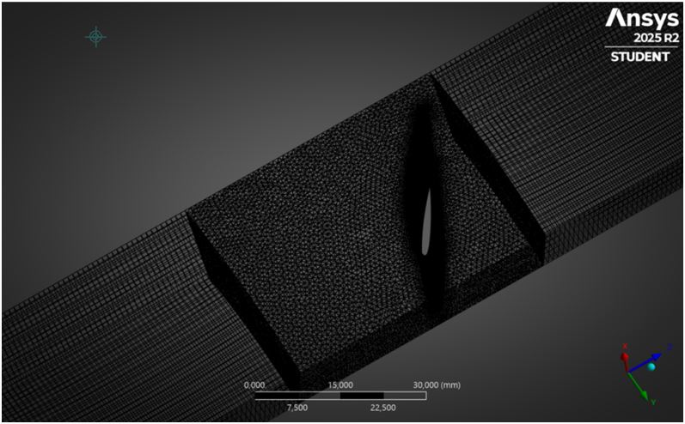

Figure-14 Mesh detailed view of 3D CFD study for single rotor.

A locally refined mesh was applied around the airfoil to accurately capture the boundary layer development and strong flow gradients in the near-wall region. The mesh density was significantly increased along the leading and trailing edges, where rapid changes in velocity and pressure are expected. This fine mesh resolution around the airfoil ensures improved prediction of aerodynamic behavior, while a gradual coarsening toward the outer domain maintains mesh quality and computational efficiency.
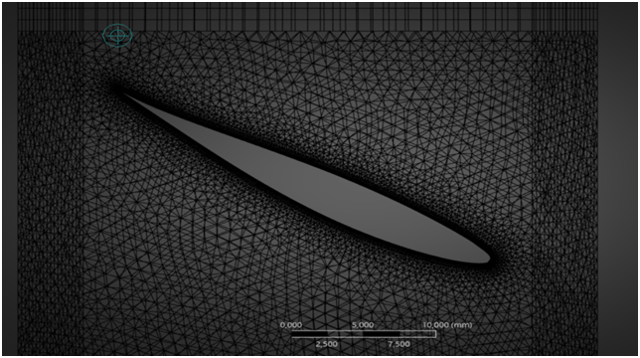
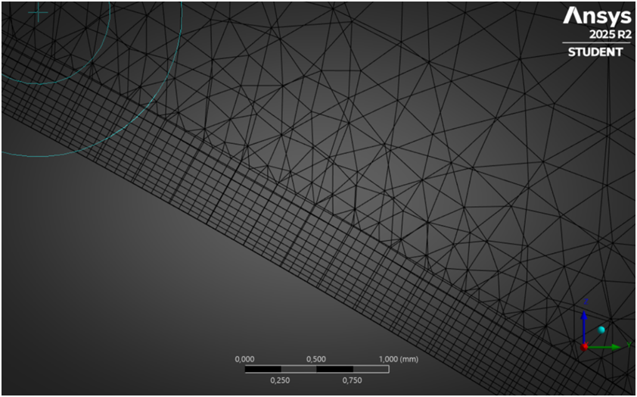

Figure-15: Boundary Layer mesh

Analysis Setup
In this study, the Transient Blade Model settings were defined to accurately capture the time-dependent flow behavior. The transient solution was performed using the Time Integration method, allowing the temporal evolution of the flow field to be resolved.

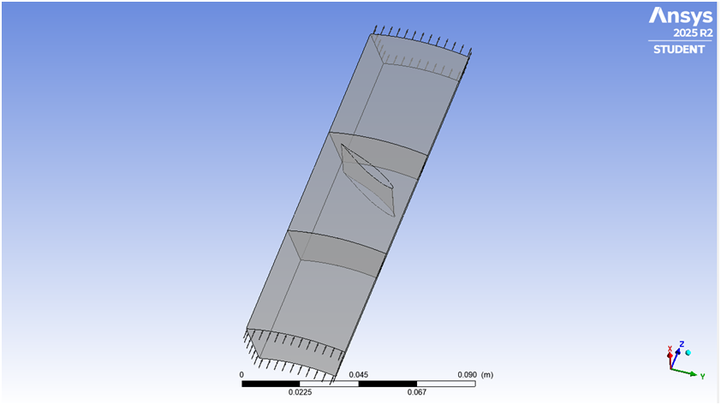

Figure-16 Schematic view of 3D CFD study for single rotor Boundary condition.
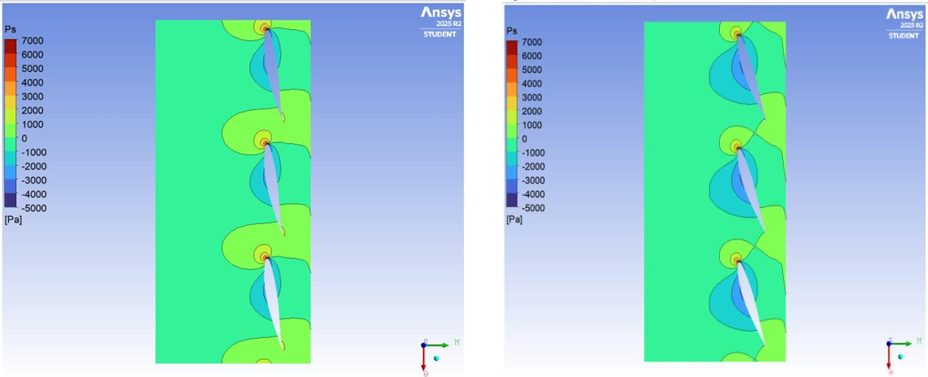

Figure-17: Static pressure contours for 10°, 20° Angle of Attack

Figure 17, 18 represents the static pressure (Ps) contours at 50% span obtained from simulations performed using ANSYS CFX and Fluent, shown in the order of 10°, 20°, 30°, and 40° angle of attack, respectively. At 10°, the static pressure distribution around the airfoil is smooth and well balanced, with a clear pressure difference between the pressure and suction sides, indicating attached flow and stable aerodynamic loading. The 20° case exhibits an increased pressure gradient, particularly on the pressure side, reflecting higher lift generation while still maintaining an organized flow structure 48 For 30°, regions of low static pressure on the suction side become more pronounced and expand downstream, suggesting stronger adverse pressure gradients and the onset of flow separation. In the 40° case, the static pressure field is highly distorted, with large low-pressure regions and sharp pressure variations around the airfoil, clearly indicating severe separation and highly unsteady flow behavior. Overall, the comparison shows that 10° and 20° provide more favorable and stable static pressure distributions, whereas 30° and especially 40° lead to degraded pressure characteristics and reduced aerodynamic performance.

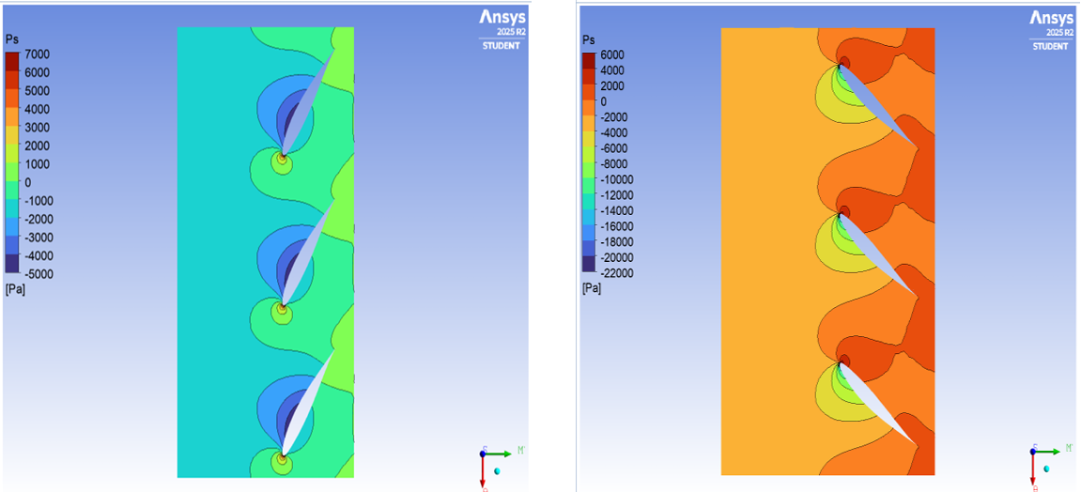

Figure-18: Static pressure contours for 30°, 40° Angle of Attack
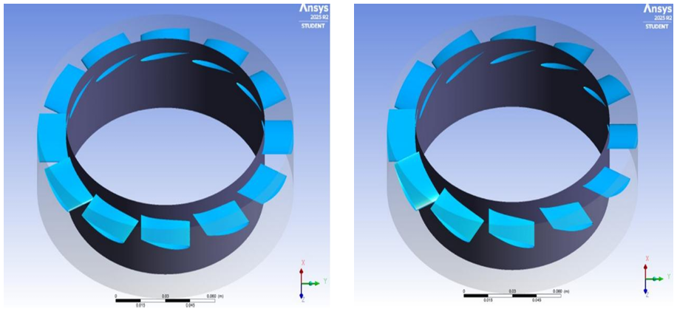

Figure-19: 3-D Representation of rotor for 10°, 20° Angle of Attack

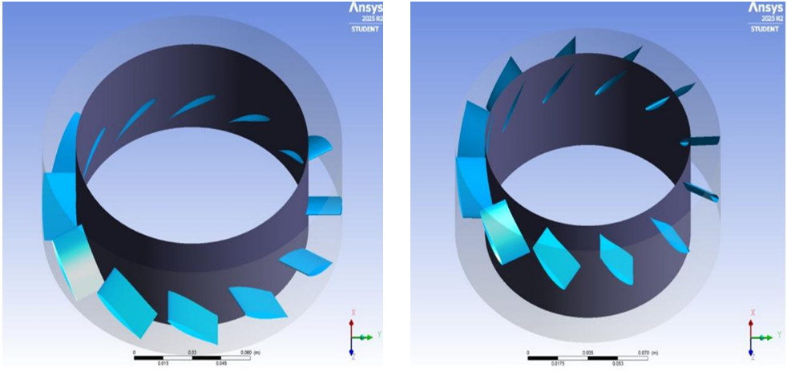

Figure-20: 3-D Representation of rotor for 30°, 40° Angle of Attack

For the boundary setup, the P-Total Inlet / P-Static Outlet template was applied: the inlet was defined with a total pressure of 0 Pa and a total temperature of 300 K, with flow direction set normal to the boundary, while the outlet was specified with a static pressure of 0 Pa. In addition, the rotor–stator interaction was handled using the Stage (Mixing-Plane) interface type as the default, ensuring appropriate flow transfer between rotating and stationary domains.

Table-3: Boundary setup

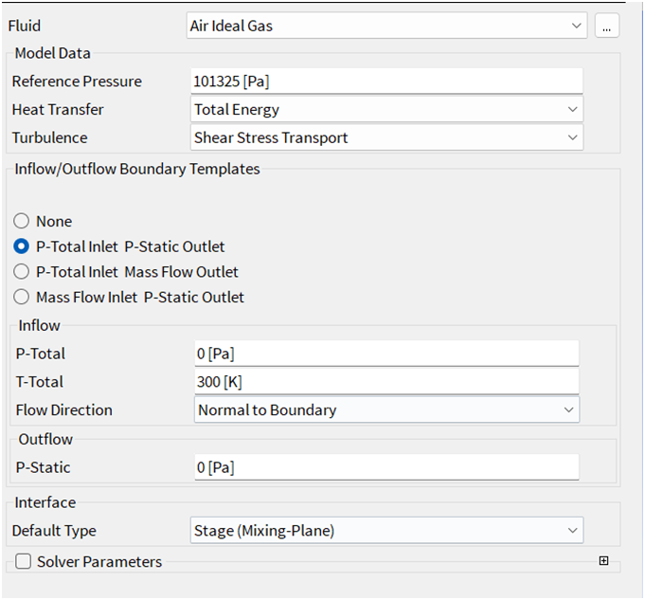
Performance Results
Table-4: Performance results for 30° Angle of Attack
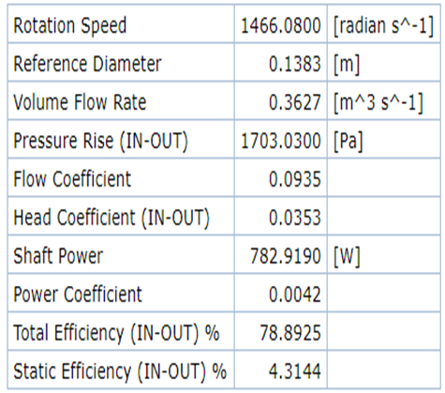
Since force was computed for single blade to obtain total Lift result was multiplied by number of blades of rotor:
$$L_{total}=L_{3D}×N_{b}=0.404×12$$
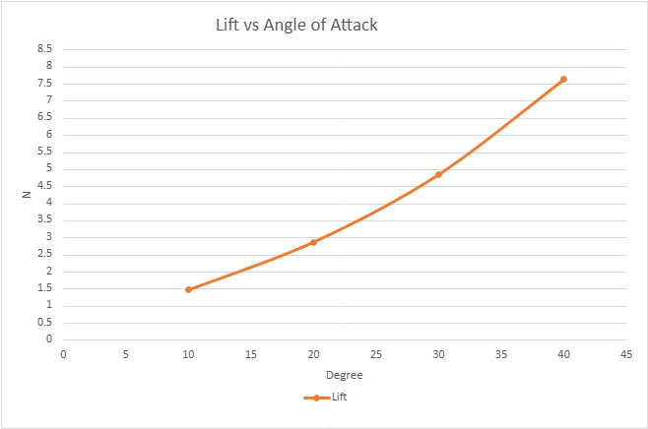
Figure-21: Lift results of 3D Analysis

3-D Model and Prototype testing
The main purpose of 3-D Modeling part is optimization of geometrical properties of the duct and rotor
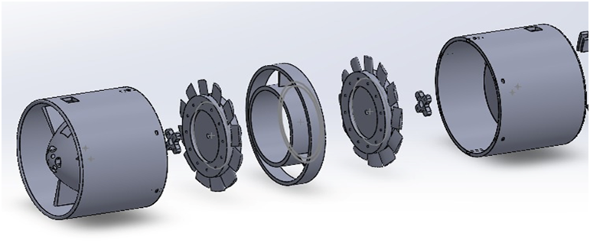
Figure-22: Exploded view of complete Ducted Propeller
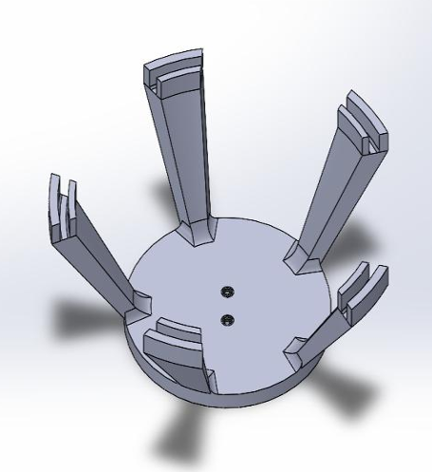
Figure-23: Testing platform
Testing platform (Figure-24) was created to fixate Ducted Propeller during operational testing

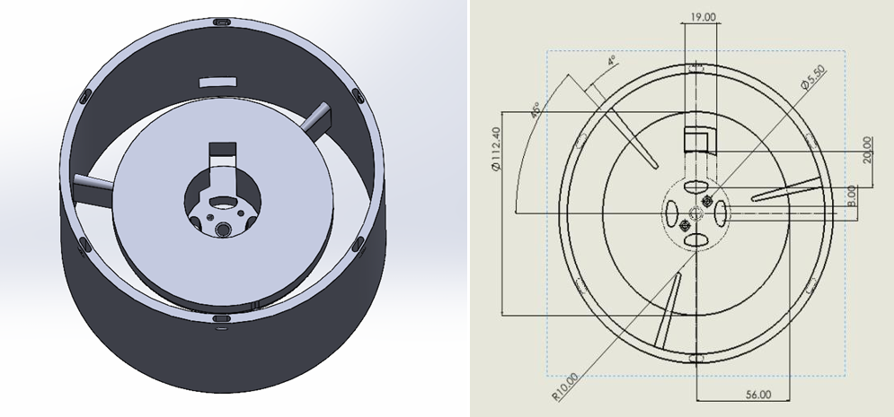
Figure-24: Top view of duct

The motor socket has the diameter of 39.00 mm to ensure a precision fit with the motor to avoid excessive vibration
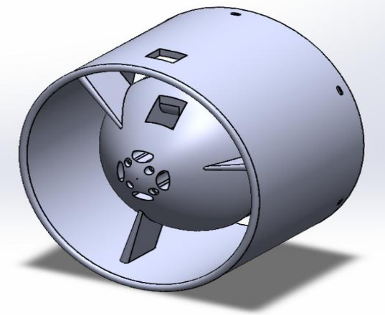
Figure-25: Perspective view of duct
Special holes (Figure-25) were created on the back side of motor socket for additional cooling dooring operation
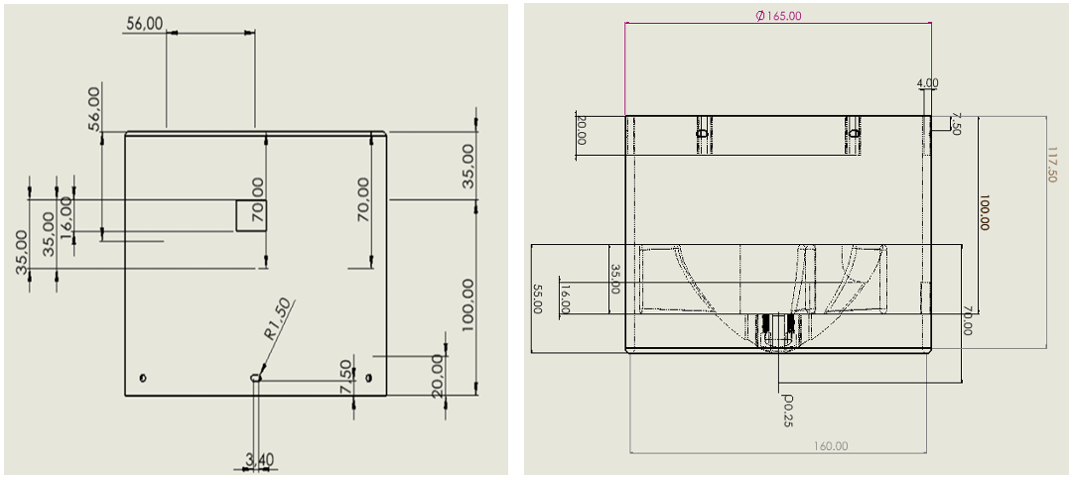
Figure-26: Duct dimensions

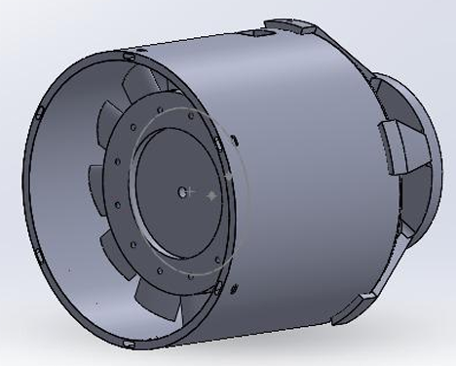
Figure-27: Testing setup model
The fan is driven by a SunnySky X2820-6 motor with a maximum rotational speed of approximately 16,000 RPM. Normal operational rotational speed is approximately 10 000-12 000 RPM
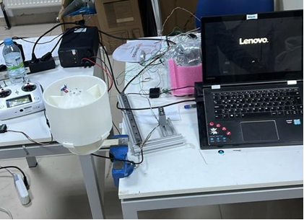
Figure-28: Testing setup
Analysis of real model was performed using NI Max program (Figure 28). Strain analysis of NI Max measure material deformation by detecting electrical resistance from bonded strain gauges, deflection is converted to force after.

Table-5: NI Max workspace
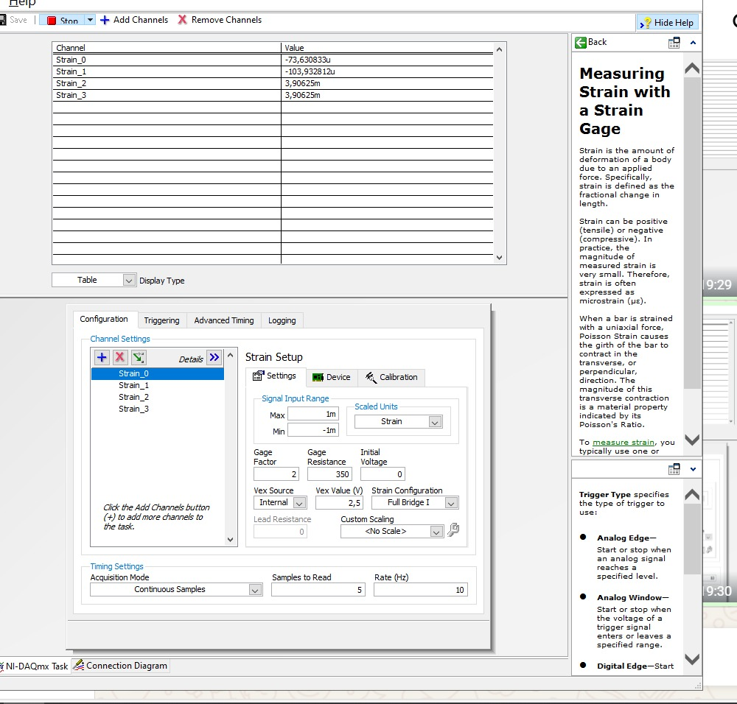
Table-6: NI Max measurements for 30° Angle of Attack
Strain change from –86.62 to –73.34 give approximate Force of 1.40 N for 30° Angle of Attack
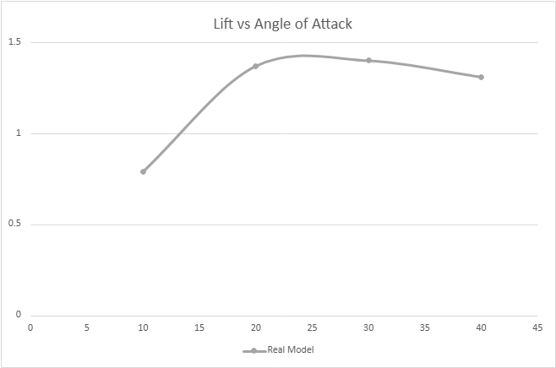
Figure-30: Lift measurements

APPLICATIONS AND EVALUATION
Additional research activities
Additionally, research with extension of rotor radius was conducted for 2-D CFD analysis. Main goal of this study is to investigate advantages of radius extension
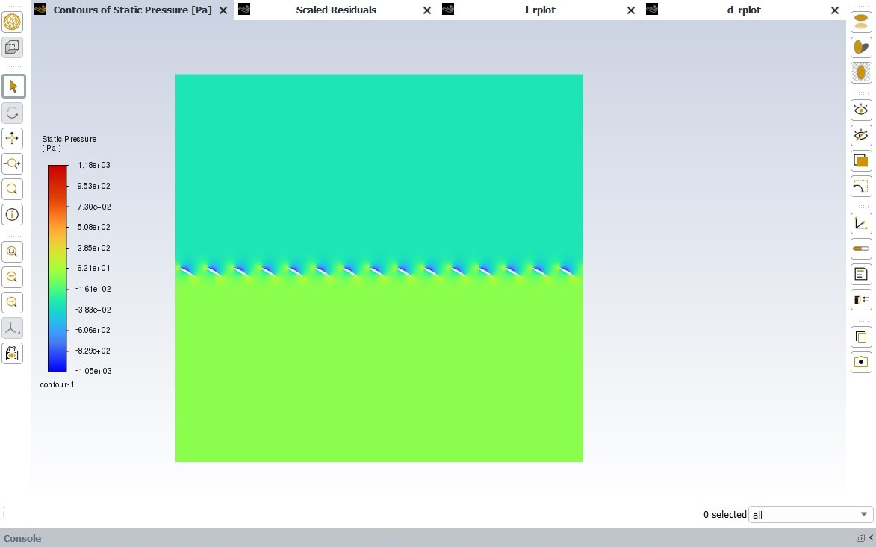q
Figure-31: Contours of Static Pressure of extended rotor Radius

Table-7: Results of extended rotor Radius.
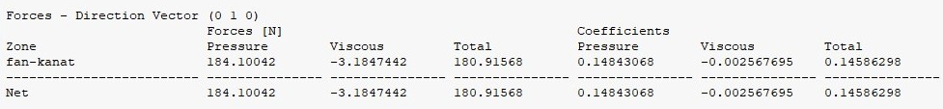
Comparison of results

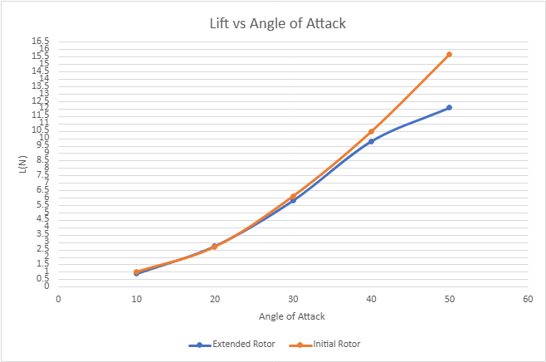
Figure-33: Comparison with initial size rotor

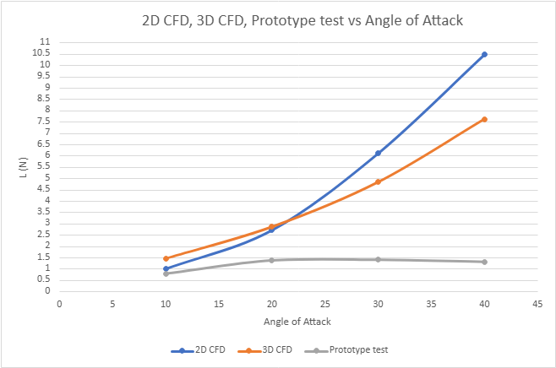
Figure-34: Comparison of main studies
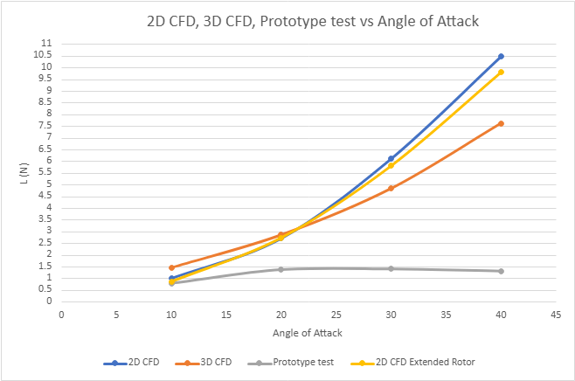
Figure-35: Comparison of main studies. Extended Rotor 2D analysis included

Table-8: Thrust Value of different solution
α | 2D CFD | 3D CFD | Prototype | 2D Extended
10° | 0.98 N | 1.45 N | 0.79 N | 0.86 N
20° | 2.7 N | 2.85 N | 1.37 N | 2.73 N
30° | 6.1 N | 4.83 N | 1.4 N | 5.8 N
40° | 10.46 N | 7.62 N | 1.31 N | 9.79 N

Current research activities
At current moment HPROP team is on stage of active development of coaxial rotor system analysis. Meshes for 2-D and 3-D are created (Figure-36, Figure-37). Preliminary results (Table-8) for 2-D are obtained but require to be analyzed and polished. 2-D CFD will follow the same methodology previously applied in the single-blade analysis. 3-D CFD mesh is currently under active development. Meshes shown (Figure-38, Fugre-39) are not at the final stage and could be modified or changed, However, the general approach of analyzing single segment of rotor will be maintained to obtain result

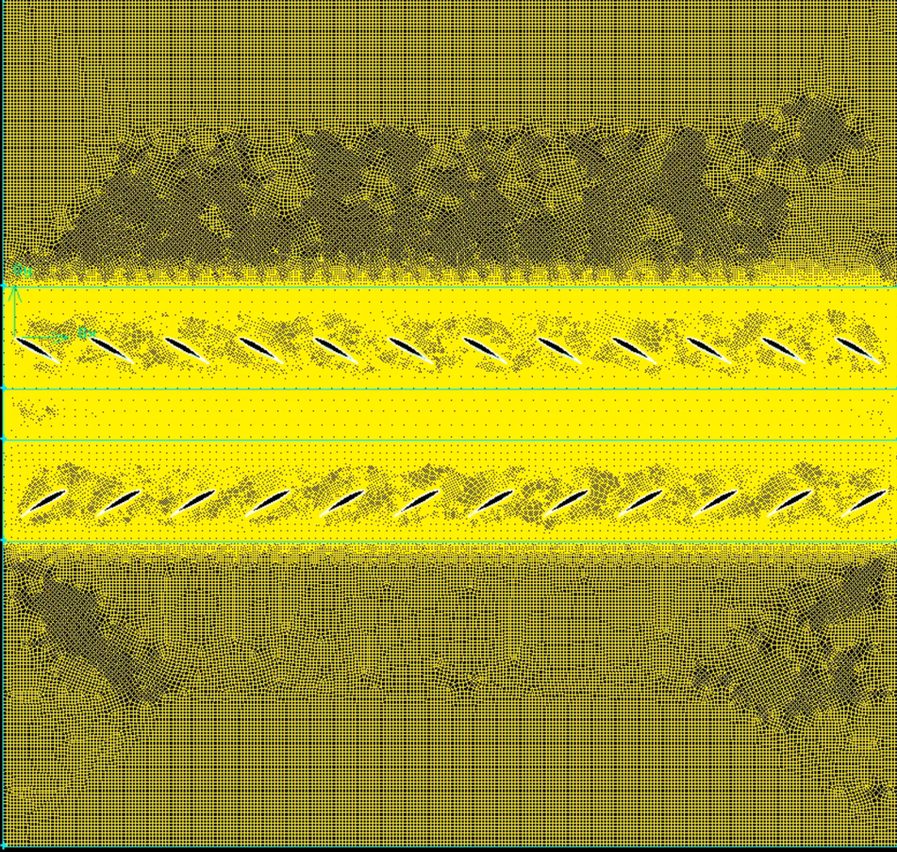
Figure-36: Mesh for coaxial rotor system

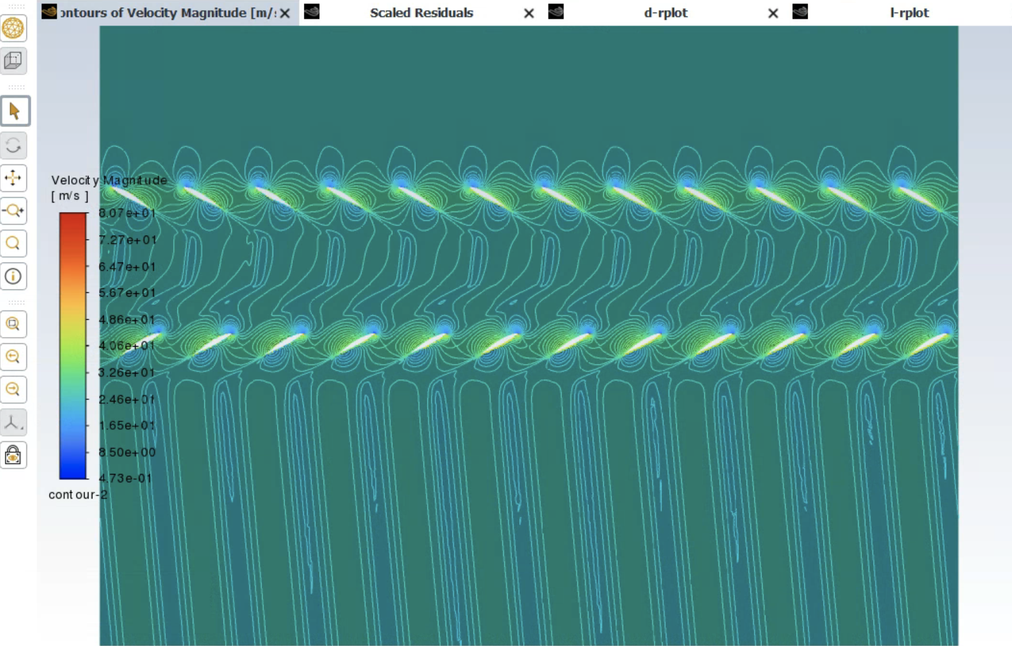
Figure-37: Contours of Velocity Magnitude of coaxial rotor system
Table-8: Preliminary Velocity output for 2-D coaxial rotor analysis
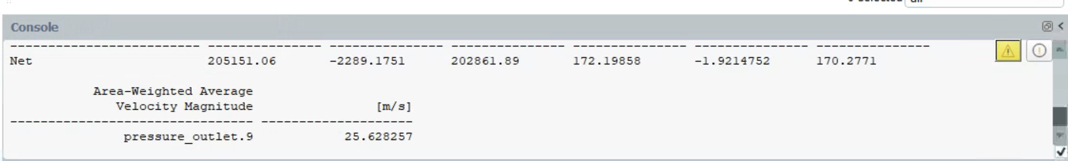
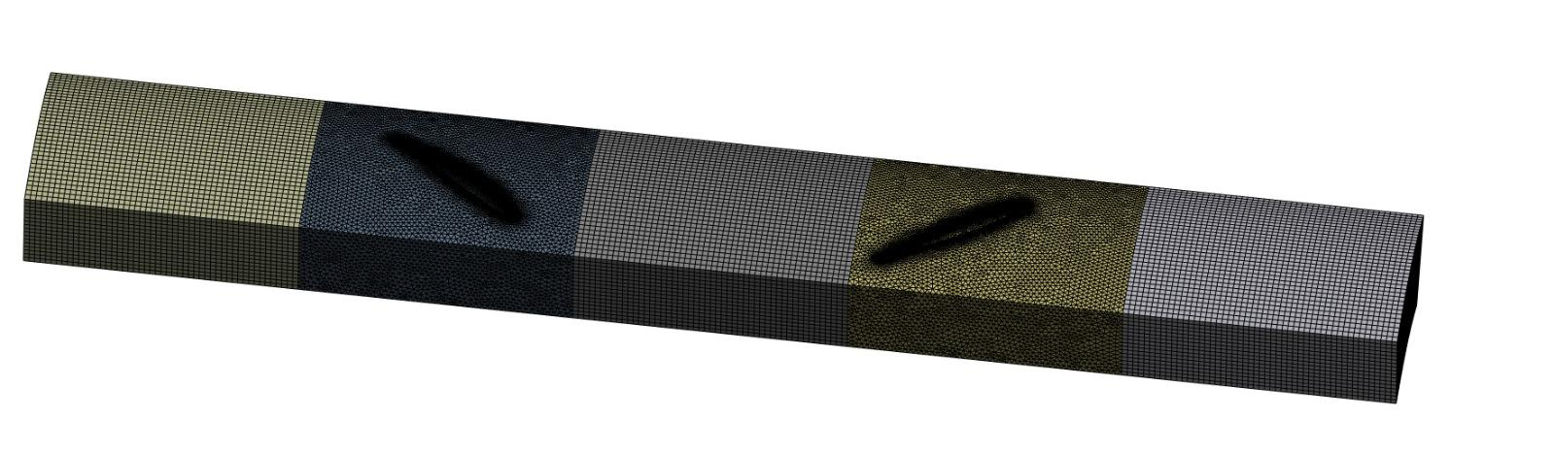
Figure-38: Mesh geometry for 3-D single blade coaxial rotor analysis
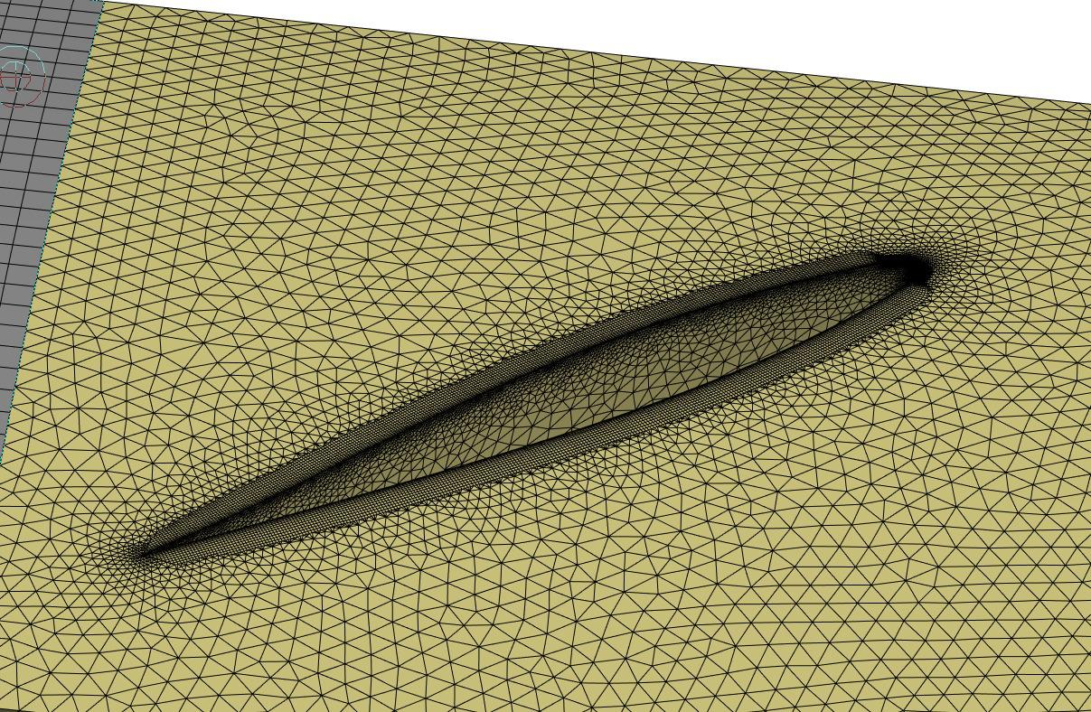

Figure-39: Boundary layer detailed mesh structure

CONCLUSION
At the range of 10-20° Angle of Attack, we can observe decent convergence of 2-D and 3-D studies. However, after 21-22° we can see that 2-D data is increasing more than 3-D. The difference could be caused by complex dynamics of 3-D fluid behavior, while 2-D provides ideal scenario. The experimental data for the Prototype Test reveals a significant divergence from numerical predictions at higher angles of attack. While the 2D and 3D CFD models suggest a continuous increase in Lift, the physical prototype exhibits a clear stall characteristic beginning after 30°. It might be caused by mechanical imperfections of rotor blades and inappropriate clearance that is planned to be fixed in future development. Further analysis of 2-D and 3-D also will be conducted to obtain more details about flow behavior of Ducted Propeller. In this article, a single rotor analysis was shown. At the present time our team is working on Co-Axial rotor development.

References

1. Cai, H. et al. (2022), Numerical Prediction of Unsteady Aerodynamics of a Ducted Fan UAV. Shows that a ducted configuration can improve thrust and reduce power consumption compared with unducted coaxial propellers in UAV applications.
2. Jack D. Mattingly, Hans Von Ohain (2006). “Elements of Propulsion, Gas Turbines and Rockets”.
3. John D. Anderson, Christopher P.Cadou (1970). “Fundamentals of Aerodynamics”, 7th Edition
4. Mendenhall, M. R. (1970), Theoretical Study of Ducted Fan Performance. A foundational study explaining how duct geometry and internal flow characteristics affect ducted fan/propeller thrust and performance.
5. Saeed Farokhi (2014) “Aircraft Propulsion” 2nd edition.
6. Van Zante, D. E. et al. (2015), Modern Design and Performance of Counter-Rotating Open Rotors. Discusses the aerodynamic basis of contra-rotating propellers and highlights how wake/swirl recovery can improve propulsive efficiency.

