All rights reserved.
State registration certificate of
the intellectual property body
№ 188 as of August 28, 2002.

Research Manager
PLP «Interactiv Kazakhstan» N. Kudaibergen

Author of scientific developments,
Corresponding member of International
Economic Academy of Eurasia A. Kamenev

INFORMATION
To G-Global project under the motto: «Provide preemptive and qualitative intellectual accompaniment of geopolitical initiative of the President of the Republic of Kazakhstan, N.A. Nazarbaev, on development of the
global crisis management plan!»

Astana – April, 2012

«… new format - G-Global, is a wider area for searching solutions of the current problems of the world financial systems and working out of the UN systems comprehensive crisis management plan"

RK President, N.A. Nazarbaev,
March 2, 2012.

«The key question of the modern policy – the question about the state destination».

From N.A. Nazarbaev’s speech
at Congress XIV of
PDP «Nur Otan», Nov.25, 2011

«We are a Eurasian country, having its own history and its own future. Therefore our model will not be alike to another one. It will include achievements of different civilizations. We will not be faced with the question: either that or another. We will be dialectical and start using either that or another, adopt the best achievements of all civilizations which have proved its efficiency in practice».

RK President, N.A. Nazarbaev
«Kazakhstan – 2030» Strategy
(October, 1997)

Contents

Recommendations about G-Global project realization under the motto: «Provide preemptive and qualitative intellectual accompaniment of geopolitical initiative of the President of the Republic of Kazakhstan, N.A. Nazarbaev, on development of the global crisis management plan!»……………………..………………………………………....5-9

From the author ..............................................................................10-11

1. Global crisis is as «Wit Works Woe» of people. About the method of calculation and minimization of sorrow quantity by means of mind quantity growth ….………………………………………………. 12-19

2. Standard peculiarities and main stages of the made scientific and applied research………………………………………....................20-26
3. Main innovative characteristics of the researches’ results, their standard and universal practical importance.....................................27-35

4. Standard legal statistical clusters – a basis of integration of civil society and effective government …................................................36-44

5. Strategy – 2030 as a basis of a clustering of data of legal statistics and special accounts ………………………............................................45-46

6. About efficiency and feasibility of researches’ results today........47-59

7. Issue of the day, new forms and implementation methods of coordination functions by government to protect the rights and freedom of citizens.......................................................................................... 60-67

Instead of the conclusion ..................................................................68-76

At recommendations contest for G-20

Recommendation of G-Global project under the motto:
«Provide preemptive and qualitative intellectual accompaniment of geopolitical initiative of the President of the Republic of Kazakhstan, N.A. Nazarbaev, on development of the global crisis management plan!».

Methodological and scientific applied basis of recommendations about necessity of implementation of G-Global project under auspices of the UN with the motto: «Provide preemptive and qualitative intellectual accompaniment of geopolitical initiative of the President of the Republic of Kazakhstan, N.A. Nazarbaev, on development of global crisis management plan!» is the result of 30-year studies of A.A. Kamenev directed to creation of a standard and unified spatially time (cybernetic) model of a constitutional state as «alive spatial organism». (Information about the researches’ process and results applied).
As it is known, in October, 2011 at the meeting of the UN Security Council the President of the Republic of Kazakhstan, N.A. Nazarbaev (2011) made a suggestion about development and implementation of the global crisis management plan all over the world.
Objectively positive scientific and practical decision of this goal is the object and priority №1, the point of honor, duty and obligation for all intellectuals of the world.
Taking it into consideration the practical sense of our recommendation is directed to involvement of intellectual potential of the planet’s population into active geopolitical and global household circulation by means of:
the first stage, - overcoming of global philosophical and methodological crisis at the expense of «restart» and transformation of people’s mind into the format of natural adequate spatial perception of 3D and spatially time thinking which is not lower than 4 D;
the second stage, – arrangement of a natural scientific decision and accompaniment of a great number of standard intellectual goals of the world community at stages of implementation for a new innovative «conveyor».
In fact it is offered to discuss the question at the 5th forthcoming Astana economic forum, then by means of G-20:
- recommending the UN officially to approve Astana economic forum initiative on creation of electronic geopolitical public movement of the intellectuals in the framework of G-Global project under the motto: « Provide preemptive and qualitative intellectual accompaniment of geopolitical initiative of the President of the Republic of Kazakhstan, N.A. Nazarbaev, on development of global crisis management plan!»;
- requesting the UN about delegating the given geopolitical public movement of the intellectuals and its special G-Global project with legal status of the UN Plan for Expansion (UNPE) called to solve the very important object of the humanity on overcoming of the global crisis.
UNPD legal status will be a guarantee against intervention of private individuals, transnational corporations and states into the process of development and implementation of global crisis management plan. Besides at the beginning it will allow providing its stable financial and material provision in favourable geological and legal regime.
The main methodological and organizational-methodical principle of G-Global project will be the full renunciation and prohibition of using methods of politicized exchange of information and giving subjective assessments according to the results of informational interaction. First of all it will be done by means of establishment of universal priority and total diktat of natural laws, standards or models, norms and guidelines of nature, criterion, and units of measure and methods of evaluation.
A lot of different initiatives are offered in the world public political practice and practice of law. However because of lack of natural scientific basis and «human measurement», most of them «die» at once.
That’s why the technology of forestalled, open and constant intellectual supply is offered where the effect of mobilization of efforts and integration of knowledge of intellectuals all over the world will be based on the method of construction of mathematically ideal model and extrapolation of its projection in reality.
To this effect in 2002 we have worked out and registered A standard clustering legal statistic model of an informational space-time sovereign state as an intellectual property body which has no analogy in the world science and practice till this moment.
This model allows organizing and having intellectual supply in electronic regime by means of exhibition on G-Global site in this case:
On the one hand, - a strategic aim in the form of a standard but mathematically ideal clustering legal statistic model of informational space-time that is the version of «elegant» Minsk space-time (1914);
On the other hand, - efficient-tactical «targets» in the form of a standard but physically real clustering legal statistic model of informational space-time, that is the version of «curved» Riman space-time.
Thereby the methodological basis of the new system of intellectual supply will be compiled only from postulates and methods of modern natural science because:
- any space-time has three main features such as dimension, topological features and metric characteristics, a composition of parameters which are invariable through time, but magnitudes of parameters are constantly changeable and thus reflects speed, tendency and quality of the state development:
- constant transformation and conversion inside of physical real legal space-time, for example, labour into product or vice versa, intellect into money, money into labour and etc., occur exceptionally in the framework of process of three laws of preservation (mass, energy and impulse) and 10 principles of symmetry. Theoretical potential of these postulates is system full and more than sufficient for a qualitative philosophical and mathematical description of any event and process, and the most important thing is that their politicized interpretation and giving their subjective evaluation become unnecessary.
The global innovative meaning will be given to implementation of the method of construction of one and united system of legal statistic coordinates into all levels of information exchange and informational people interaction without any exception that is «a Russian doll» from 6 information spaces: Person – Family– Group – population aggregate – State – the Universe.
In our judgment the greatest geopolitical practical effect from usage of the model will be obtained in the framework of the UN during execution of initiative of the President of the Republic of Kazakhstan, N.A. Nazarbaev, on development and implementation of the global crisis management plan.
It has been approved that the final result of the given goal realization will be establishment, formation and implementation into practice of the united integrated World Bank of natural legal standards, units and means of «human measurement» of humanity development, legal statistic algorithms, standards of information exchange and information interaction.
The most important tendency will be a creation of a global electronic information system where its technological core will be a clustering model (electronic duplicate) of the real legal statistic space-time. Its software will execute the function of some public «head» with an artificial intellect based on absolute operation of law of large numbers (law), laws of chance (statistics) and mechanics principles (logic).
From the position of firmness of democracy development processes and human rights protection it was determined that in the nearest future States will perform functions of a systems administrator and moderator in the sovereign information space-time but the function of the Subject of law with administrative authorities they will execute only in special cases and only in case of settlement of contingency (regulation).
We consider that the offered Information of the given project is sufficient enough to make a positive decision about further recommendation promotion. In our opinion the form of «human» statement used in it will give everybody an ability to realize, first of all, the sense of the offered ideas and decisions, to give readers a rise not only to doubt but to confidence in themselves and creative activity.
The given Information is increasingly a product of impromptu and is based on understandable scientific ideas so cannot be accepted as an innovation in the field of theory. However, innovation can be clearly seen in determination of the method of semantic and substantial interpretation of achievements of modern natural sciences (cybernetics, theories of space-time, relativity and etc.) as well as in creation of the method of their usage in policy and state-legal formation.
It should be noted that the developed pictures of clustering models and technological schemes, some definite mechanisms of legal statistic installation-specific settings of space according to intended function, conversion and visualization of legal statistics data in regime of real time made by A.A. Kamenev and given in Information have no analogy till this moment.
Further elimination of defects and continuation of scientific researchers are going to be in the regime of «national work», that is by means of participation of the authors of the given recommendation in creation of the worldwide intellectual property body.
From this point of view it is recommended to create an international electronic innovative Centre on development and implementation of scientific and technical production in the formats of 3D, 4D on AEF basis and in the framework of G-Global project. It is understood it is used with the program which allows keeping records, carrying on measurement and evaluation of work done by the intellectuals irrespective of place of residence, registration of their copyrights, evaluation and remuneration of labour by final results
Taking into consideration many other geopolitical initiatives the long-term creative and effective innovative style of sovereign state governance there appears to be sufficient reasons for further promotion of G-Global project into the UN at the same time to recommend the author of the geopolitical initiative on development and realization of the global crisis management plan of the President of the Republic of Kazakhstan, N.A. Nazarbaev, as a main research manager of the special UN Plan for Expansion (UNPE).

Research Manager
PLP «Interactiv Kazakhstan» N. Kudaibergen

Author of scientific developments,
Corresponding member of International
Economic Academy of Eurasia A. Kamenev

From the author.

Some years ago Nobel prize for physics was awarded to a scientist published the work «Can the flapping of a butterfly in Brazil become a cause of a tornado in Californium?». The strict physical and mathematical estimations proved that generally it can be done not only by a butterfly but all other bodies and representatives of natural world except people.
If a scientist investigated the question «Can the idea voiced by a person that is an insignificant activity become a cause of a political and real tornado in the world?», it is doubtful that his work would attract somebody’s attention because the answer would be evident: It can be but as a famous physicist, N. Bohr, told it might be «a mad enough idea».
The scientist effectively used in his interest that in a real world only people allow behaving irresponsibly and perverted. Thus for a thousand years they practice «sovereign-free» lawmaking and execute it in the regime which evidently ignores conditions and demands of environment (universal space-time).
The scientist’s consideration was justified that none of people would ask a question about responsibility of any butterfly which could become a cause of a tornado in California.
Thereby such an unusual name of the work is not more than an advertising gimmick directed at getting a high evaluation of «hollow» but at the same time a really important physical and mathematical work of the author, a laureate of Nobel prize.
In contrast to him as far back as the Middle Ages a great philosopher and mathematician, G. Leibniz, investigated human deeds and established «Mistakes of most people are the result of ambiguity of word and aimlessness of their tests». Desire to help descendants to stop such a deformity, he created a theory of systems and discovered a method of integral calculus in Mathematics.
It is terrible to say that the theory of systems stated by him and in space-time interpretation is still unclaimed. So integration policy at worldwide level is realized irrelatively and nonregistering of knowledge of world Philosophy and Science. Economic, legal and other spaces are created by means of making agreements and contracts «about mutual understanding» that is above all mathematical models and carrying out of any integral calculus.
Generally the current global crisis is «Wit Works Woe» of people. Even at the beginnings of life people’s Mind was infected with the virus of private property and egoism whereby «heads» of politicians and scientists became some «generators» of vicious ideas and projects long ago, and «heads» of their executors have nearly lost ability to see and suppress vices.
Such a mental disease and its treatment mode have been known to everybody and for a long time. Thus an ancient Chinese parable tells how a Pupil asked Confucius: «What would you do, the Teacher, if you were appointed as a ruler?». Confucius answered: «I would restore words their primary meaning».
It should be noted that Confucius set a problem «restore words their primary meaning» whereas all modern «influence factors» and a geopolitical mechanism in whole demand from «developing» countries endless reforms and elections by means of «inventing» of new words for them or imparting of new meaning to old words.
Somehow or other the problem of independent, group or mass wandering of people in the labyrinth of mistaken notions, imaginary knowledge and values always exists. There is no solution but the cause is known to everyone: most scientists, politicians and officials do not wish to leave this labyrinth as far as in the world of exact knowledge and strict order (justice) they cannot feel as called-for and unpunished as it was before.
No great loss without some small gain, indeed. The global crisis burst out something like they won’t lock the barn door till after the horse is stolen.
How long they will do it (cross themselves) – nobody knows. I do not deny a possibility of their miraculous enlightenment and consider that it is necessary to act on the premise that finding of practical problem solution related to leaving the labyrinth of ignorance will be personal responsibility and duty for everyone who lives now and for those who have already died and will be born in future.

Chapter 1. Global crisis is as «Wit Works Woe» of people. About the method of calculation and minimization of sorrow quantity by means of mind quantity growth

As long ago as Pythagoras, Plato, Socrates, Aristotle and other creators of a dialectical method of Nature knowledge that is a mechanism of the Universe space-time. At that time such postulates as «a person is a measure of all things», «the world is numbers harmony», «Geometry is a science about politicy», «the God always geometrizes», and etc. were created and conjured descendents by literal.
However long before it took place humanity has chosen and are still guided by the opposite and evidently uncivilized and antiscientific postulates: «money is a measure of things and people», «world is a competitive environment of survival», «politics is a dirty business», «a state is a mechanism of coercions», etc.
For a thousand years the public laws norms have had priority over the natural law norms and ones solved the aims of militarists, monetarists and adventurers. Demands of law of Nature, observance of natural valuations and standards were executed by «everyone as far as spoiled» whereas personified calculation of «contribution» into forming of the existed global crisis wasn’t calculated. The ochlocratic equality and the universal irresponsibility prevailed over interests’ transparence all over the world.
It’s for that the problem of a scientific method creation (algorithm) became topical which allows defining the quality and efficiency of every person’s influence on development of «a Russian doll» of closed spaces: family, corporative, territorial, state and world ones in whole.
If to look impartially Kazakhstan is one of the countries which are very close to overcome the situation such as «Wit Works Woe». Many geopolitical initiatives, conditions and demands of the policy of RK President, N. Nazarbaev, prove it. People all over the world consider and it is absolutely rewarded that his decision to close Semipolatisk nuclear firing ground (even it was the 4th one in the world in rank) and refusal from nuclear weapons were really so wise. It became a worldwide historic event.
However in our opinion there are a lot of initiatives and decisions which are as wise as the mentioned above and have a global innovative and practical usage but are still disregarded.
Thus 15 years ago the Committee on legal statistics and special calculation in the framework of RK General Prosecution Office was created by the Decree of RK President. All over the country this body on continuing basis and in an organized way had to carry out collection, treatment, storing and provision of information related to events and processes having a legal meaning.
Till now nobody could create an identical analog on formation of such statistics and creation of such an authorized state body. Though everybody complaints of transforming global electronic communications into «informational damps», of missing domestic informational content which can be generated, renewed and guaranteed by the state in respect of quality
It is probably that in the nearest future a true potential and innovative meaning of this decision made by the President and the state experience will be in demand among all geopolitical bodies and states all over the world.
So the most important thing is a conclusion made by RK President at Congress XIV of NDP «Nur Otan»: «The main question of modern policy is a question about a state destination … Restoration of just order will be a basis of the post-crisis world».
In fact the Head of the state demanded to improve quality and efficiency of mathematical supply in the sphere of legal state relations, legal entity and individuals of the country till the appropriate level because there are no other ways to state a just order and cannot be.
If to look impartially it is time to throw back and add notions of ancient scientist about information picture of the world to one’s armory where they intuitively but clearly depict:
- «a Russian doll», which represents a united mechanism of information exchange and interaction: Person – State – the Universe but has three levels of normative and legal regulation as minimum;
- an average Person who will be defined as an aim, a unit of measure and a criterion of condition evaluation (in whole – integral) of a State in two systems of legal statistic coordinates at the same time: ideal (in Mathematics - Minsk space-time) and the real (by people of Rimanov’s “curved” space-time) Universe space-time.
The modern global crisis is man-made and its first source as saying goes «as well be hanged for a sheep as for a lamb» is extremely related to as people say inability of politicians and scientists reason soundly from birth.
Let’s take an example. In one of RF Federal Meeting message the former RF President, V.V. Putin, firmly stated that «the state and people don’t understand each other».
As a result modeling and analysis of the acting practice of information exchange and states interaction with their citizens were defined as follow:
Natural mechanism of reception, treatment and exchange of information on the Universe scale is standard, unified and consists of 7 components.
A person as a subject of cognition and «a measure of all things мера» has 6 sense organs, but his brain possesses the 7th ability which allows him integrating 6 flows of information received from environment into one (to think and to conclude).
Nowadays all developed and developing countries are carrying out exchange of information and interact with their citizens using only two from six sense organs that is eyesight and ear by means of television.
So it gives only 2-D (two dimension) perception and only alternative (comparative) thinking.
Thinking is a synthesis (integration) process of 6 information flows into one and the 7th algorithm of behavior. Quality and efficiency of thinking shall be measured and evaluated not as a flow of words (demagogy) but as a final result (7-measured result) of a Person’s deed in environment.
It was used by Pythagoras while solving problems of environment cognition through multidimensional information perception, in volume and in movement that is simultaneously:
- in color (eyesight), in sounds (ear) and with a glance of fragrance (sense of smell):
- with a glance of all spectra of tactile, gustatory and other sensations:
- distinguishing information on the quality (subjective and objective), on the orientation (analysis and synthesis), etc:
- representing information as a physically settled force, a geometric vector and the space-time form.
Strictly following the principle «practice of the truth criterion» he was able to create a special but not measurably method of the Universe dialectics (mechanism) cognition.
Having such ideas it is impossible to understand and justify the fact that the important conclusion made by V.V. Putin is still being passed over by scientists and out of politicy and practice of governmental authorities and regulation’s reforms.
Information exchange and interaction on 3D-level and upper are not used because of technological and technical backwardness of one of the parties if to be more exactly - states. Though the problem of states modernization has technical solution and the goal is to implement a natural, standard that is 6D regime of state communication with its peoples and between themselves.
Thus it is necessary to be ready not only with the fact that for a hundred years politicians and scientist have reproached in public and are still reproaching their peoples for ignorance that is «lay» the blame on others who are their breadwinners. It is more important to understand and make a domestic conclusion that exactly here there is that great potential of human indignation which unfortunately some «hot heads» started to use «planned», for example, например, appointing «days of anger» among Muslims on Fridays.
I consider that if we take into account all highly explosive situations in the world as well as all positive and negative factors and even those about which we keep silent in public, humanity must make all 365 days of a calendar year as «days of anger ». Though people must turn their anger to themselves, to their ignorance and inability to live without frantic rash, to work with the joy of creation and to create something around themselves and only peace.
Historically it is necessary to proceed from a global crisis of civilization and critical condition of Nature in whole. Thus it will be a final result (for mathematicians – embodied in practice into algorithm and integral) of humanity activity for a hundred years.
It is necessary to stop accepting crisis phenomena and processes as occasional that is which appeared as a result of mistakes done, fanaticism or even avidity and lucre of direct predecessors – recent political leaders, parties and movements inside of the country (communists, corruptionists, bankers and etc.). They interpret all their deeds at will and with impunity, exceptionally with the position of struggle against terrorism, corruption and criminality, with connection of transnational bodies and secret services of the interested countries.
Somehow or other, mental outlook and knowledge of our citizens must be increased till that level to carry out a search of «enemies» in worldwide history of people Mind formation, to expose and eliminate «generators»of crisis phenomena and processes on the level of topical world space-time.
In History it was topical to consider «cutlets separately from flies». However in our case consideration of the global crisis as a consequence of worldwide historic process can be done as follows:
- a horizontal space-time which levels intellectual contribution into development of a crisis of different generations of both law–abiding and unbinding people;
- a vertical space-time which leads away from «through» historic responsibility of all types of people and clans who were at all times and relatively new generations executed specialized, professional and special standard functions such as explanation and interpretation of policy (scientists, statisticians, journalists), education (teachers, tutors), health care (doctors, healers), creation of condition for development taking influence peculiarities into account (parents, grandparents, friends) and etc.
If to look impartially the process of Intellect and Mind acquisition by people is identical in content but different in finding ways of Ignorance elimination. In this regard the existed law-biding citizens are picturesquely in the position of honest builders near ruins of the Tower of Babel which they have built for love of the God and as a way to be near him.
In this situation it is extremely important not to panic and be emotional, not to seek «the last» only in order to sentence as Americans to 150 years and then to console the cheated humanity with sufferings of an old swindler.
It is more useful to know that all positive and constructive decisions which are able to give a way out of the global crisis of civilization result of the response to the following question: Did we need to build that Tower of Babel? Moreover the reason «The God is in every person from the birth» initially exists and is one of the main trends of work in all religions, so our goal such as to build a road from stones «to ourselves» has no sense and vicious according to the accepted definition.
If to speak about importance there is a need to set political goals reasonably and to solve them correctly in practice. Let’s give the following example:
In October, 1997 in a long-term strategy such as «Kazakhstan – 2030» RK President, N.A. Nazarbaev, set a goal to create Eurasian information model of a state.
Immediately after that the author made a functional analysis of worldwide practice of a state and legal formation.
It was settled that both in theory and in practice states all over the world are still positioning themselves as a «coercion machinery» that is they can be defined as uncivilized in general. Vice touches states of all types and modes in equal proportions because the difference, for example between capitalistic and socialist countries, is only in the fact that the first ones like coercing peoples of other countries but the second ones do it with their own peoples
Having considered it in a broad historical meaning we made a shock but useful conclusion for further investigation: the cause of existence of all former external and internal wars, split of the world into parties at war because of religion, ideological and other reasons, triumph of global militarization and monitarization policy and as a result the existence of a worldwide crisis is concealed in a frankly felonious question: Who and How must «milk» people of that or another country or region?
Having considered it from methodological point of view we came to the following conclusion: implementation of reforms and modernization in the framework of a class doctrine of a state and law as «coercion machinery» has no prospects. Moreover, it occurred that use of class definition for a state and secular law as a basis of violence use and its excuse were prohibited.
In the capacity of a new home directory they took a depoliticized and key definition of a state as an «alive spatial organism», which was offered by a founder of geopolitics, F. Ratzel, in 1847.
This initial definition demanded directly and strictly to use a cybernetic approach and functional analysis of a state activity as well as data potential of legal statistics and special calculation. It was settled at once that a total lack of organization, chaos and bad management in the world, flourishing of criminality and corruption are consequences of synchronous and anisochronous work of a great number of «small generators» of power and management in the form of people’s thinking and mind, which can be performed either law-binding (naturally normal) behavour or unbinding (unnatural) behaviour.
Tertium non datur. It follows that legal time can be of two types and is implemented simultaneously in two diametrically opposite trends: law-biding citizens «rotate» it due to their knowledge and business by the hour, but unbinding citizens do it anticlockwise.
Correlation of indicators and potentials of legal and illegal time is not more than a coefficient of efficiency of legal system in whole. Therefore the evaluation of their real parameters and potential on a legal statistic level is an extremely topical goal having a great innovative and practical meaning for modernization of state activity all over the world. It is impossible to structure and analyze the created potential of «cutlets» separately from the decomposed potential of «flies» without evaluation of the coefficient of efficiency of their legal systems.
The results of the functional analysis demanded to reconsider fully the questions about correlation in modern legal politics and practice of standards law-enforcement of the natural law, the public law and the religious law, selection of merits and vices in mechanisms of secular states, a criminal world «the rules of underworld» and even the mob law.
All these legal systems and regulating mechanisms were polished for a hundred years. They proved viability and theirs experience is the world heritage. Thus religious science of law can have no competitors concerning ensuring of morality and justice demands in societies. The same can be said about a criminal mechanism «the rules of underworld» concerning simplicity, reliability and lack of corruption.
However it is impossible to understand why the use of modern physical and mathematical theory of space-time as well as worldwide practical knowledge of modeling, designing, creation, control and management of space-time quality are not provided while approving of a great number of existed intergovernmental and other agreements about creation of legal, economic, customs or other spaces.
There is an absurd opinion among politicians and practitioners. For example, a legal space-time is not physical and functions not according to natural laws. It being known that the norms of the secular law supposedly have priority over the norms of law of nature (depoliticized).
Meanwhile exactly this vice does not allow defining «a common denominator» in international law, unifying, classifying, systematizing and harmonizing legislative demands of different countries on a standard basis and leading them into an appropriate numeric format.
Even under the growth of quantity of «coloured», «jasmine» and other revolutions that is observing the evident use of electronic information technologies and social nets with selfish ends the majority of politicians and lawmakers cannot realize a need of creation of electronic systems of persistent legal statistic monitoring of environment quality control of citizens and state development management performed as the «alive spatial organism». From all the symptoms they have no other methods of struggle against criminality except chasing after a single offender and groups of offenders.
From the stated position the analysis of efficiency and quality of intellectual supply in geopolitics and the states’ home policy has been done. It is settled that the priority of the norms of law of nature and the diktat of natural laws demands in legal policy are not a source and the generator of the worldwide civilization crisis.
The conclusion was that the worldwide crisis is a naturally determined consequence of a hundred year-priority in geopolitics, in foreign and home state policy, supremacy of artificial values in people’s minds (secular, religious, class, criminal and etc.) of perverted criteria of evaluation, standards, units and measuring instruments.
From technological point of view the following conclusion was done: functional arrhythmia at the high level is a naturally determined consequence of lack of one or general «integrated or zero» scan point in the world information (legal statistic) space-time for all subjects of law.
Thus far, political and legal world doctrines as well as law-enforcement practice in whole come from a primitive interpretation of private property law, principles of freedom and equality of citizens as a right of every person and in all cases to choose a scan point on a basis of priority of his/her own private and other «life» interests. Though it shall be done separately, at will or not time or space-fixed.
Exactly this rule is a part of vicious management practice. As the saying goes «divide and rule». It was offered to suppress it by means of creation of an immortal worldwide system of legal statistic coordinates, of determination of an ideal (natural) vector of Nature development in it and henceforth of comparing trajectories of a real development of all states, legal entities and individuals with it.
Therefore, the aim of scientific and applied investigations shall be determination of a solution algorithm of the main organizational and legal goal on finding a way from worldwide crisis and creation of World bank of legal statistic standards, measuring instruments and algorithms of management of states, legal entities and individuals as the «alive spatial organisms».

2. Standard peculiarities and main stages of the made scientific and applied research
Some fine day the worldwide crisis will teach everyone to distinguish innovations from profanations whereupon at last intellectuals realizing necessity, methods and forms of peoples’ life activity restructure along «the lines» of natural law (universal values) and natural science (human measurement) will be in demand.
The author has made such investigations approximately for 40 years and he did them to his own cheek, without an idea to create a theory and «to promote science». I am sure that this fact shall be emphasized, my dear readers.
First of all it concerns the unique Standard structure of clusters and basic unified model of information statistic space-time of a sovereign state. (See below)
The model has been developed by means of purposeful and reasonable grouping of the world-existed knowledge and experience in the framework of physical and mathematical space-time theory.
Creation of the basic clustering information space-time model allowed determining an adjustment method of state legal mechanism which carries out such main functions as a statistic record and a legal control of safety requirements adherence; struggle against criminality; implementation of state, legal, economic, social and other programs.
From technical point of view the analog of this method is heterodyne invention that is a device for switching TV channels. It allowed to stop the vicious practice of informatization in the country and in the world which was aimed at creation of a great number of electronic information systems with a single function, for example tax-determination or statistic-form-determination.
The installation-specific-settings device will allow users creating any virtual legal statistic space-time, working with it and saving it as many times as he wishes.

Picture 1. Standard structure of ties and the basic model of clusters distribution of legal statistic space-time
of a sovereign state
(Volumetric decomposition of legislative requirements in the coordinate system, measuring units and instruments of legal statistics and special records)
SYSTEMATIZATION OF ACTIONS
CODIFICATION
registration
of facts
field of
field
field
programme
plan
RK Government
RK Parliament
RK President
legal
personified
sphere of private legal conscience
law-enforcement sphere
sphere of public legal conscience
goals of
society
2004
constitution
public interets
(executive power)
statistic
phenomena
2030
the point
of policy
type of
law
measure
content
of law
State interests
(judicial power)
goals of
the state
private interests
(the authorized power)
law
freedoms
supervision
OF CONTROL
+1
-1
3.14
3.14
+9.8
-9.8
KNOWLEDGE

Note: 1. Spheres of public and private legal conscience in whole forma virtual (intellectual) world of groovers’ ideas including condition of legality and law and order in the country. As opposed to the world of words and thoughts the law-enforcement sphere is presented as a real physical world of practical actions (legal statistic events).
2. Every top of the cube is presented as a separate cluster and in the aggregate it is a system of integrated legal statistic clusters. Figures + and - 9,8; + and -1; 3,14 are constant physical and mathematical parameters of dimension, topological characteristics and metric characteristics of a real legal statistic space-time which allow controlling and optimizing its proportions. ,
3. Colours have a practical sense and logical meaning. They serve as a key to read data on the formula «every hunter wishes to know where the pheasant sits». The clusters have a strict pair distribution according to the cube’ diagonals which correspond to three branches of power (judicial – red and dark blue, authorized – green and yellow, executive – blue and orange). «Dumbbell» of violet clusters is a «corridor» of transit of initial space to perspective (expected) that is a ruler and measuring time.

The model allowed determining the method of conversion and visualization of descriptions of legal/unlawful behaviour (statistic form) in the form of geometrical figures. Implementation of such an innovation in practice will allow using a great number of algorithms in the system of state authority and regulation which have been functioning for along time and efficiently in building, industry and other scientific spheres of manufacture in the form of systems of automated modeling, designing and management of bodies of closed and local space-time (spacecrafts, submarines, and etc).
It is evident that the economic effect will be great both at the expense of implementation and replication of means of new generation software and in the result of suppression of negligence and corruption in practice.
It should seem that existence of such an effect demands presentation and demonstration of methods of perception and thinking, explanation, execution and implementation control as well as especially multidimensional legal decisions in a the political multidimensional information space-time least of all.
However my experience indicates the opposite. All former requests such as to pay attention to the merits of cybernetic and space-time approaches were useless. As a rule, we usually react in the following way: «It can be because I don’t know it» and then we hear something like: «You were born not at appropriate time».
Thus, as far back as 2007 the author worked out a «"Roadmap» of modernization of the information system of state authority and regulation of the Republic of Kazakhstan» and the project «Conception of Eurasian information legal statistic model of state authority and regulation». In April-May, 2008 he explained the given project in RK President Administration and to the working group of RK President’s Security Council. Though there was no discussion and no decision was made. It can be explained by the singularity of implementation of space-time modeling methods in the sphere of state authority and regulation as well as lack of innovations presentation experience at this level both from my side and from the audience.
You know that it is impossible to impart knowledge if someone doesn’t wish to realize or is not ready to accept its sense and meaning..
In this situation there is no other way except «to anatomize» one’s own «head» and to demonstrate everybody: how and why it «came to such ideas».
In other words, it means to make us «scoops» come back to the initial position and then to show just a standard process of transformation of the former «scoop» into an intellectual of the new civilization «Homo Sapiens».
Well, for a start, in 1974 I became one of the laureates at the all-USSA Competition among students on the problems of social science in the State University of Kazan, by the name of V.I. Lenin.
Coming back to Moscow I knew that Moscow University of the Humanities, by the name of M. Lomonosov, opened the Department of legal cybernetics on basis of the legal faculty and I bought the book «Legal cybernetics».
At once I started methodological and applied investigations which were directed as now said to the creation of information technology of regulation and a natural-science state model «alive spatial organism». I should emphasize that I am still doing all investigations at the expense of my family, relatives and friends funds.
I anticipate but answer without comments that at the moment this trend in science and practice is a core and a logical bar of RK President’s idea, N.A. Nazarbaev, stated at his inauguration, about creation on the base of the Republic of Kazakhstan of a Eurasian model of an information state having four dimensions.
In 1977 during the nationwide discussion of the project of the USSR Constitution I gave a report to CC CPSS public chamber where I offered to define the Constitution as a main algorithm of the state development that is in accordance with the definition of a famous mathematician, A.A. Markov: «Directions unequivocally define the way of some constructive processes».
In order to suppress of numerous politicized and pseudo-scientific legal discussions on content, structure and forms of the Constitution interpretations, interaction with other regulatory legal acts and etc. I offered to follow the well-known mathematical theory of algorithm creation, and to consider laws and subordinate regulatory acts as derivatives and secondary from the main algorithm.
It is necessary to note that nowadays when we live in conditions of the worldwide integration and informatization, necessity of processes unification and harmonization of information flows within nets of «electronic governments» the goal of regulatory legal acts algorithmization that is their conversion into language of Mathematics is the key and the main method of modernization of states all over the world and the creation of the worldwide information legal statistic system.
In October 9, 1990 I informed President’s High Economic Council about this fact and other results. The press-service prepared the interview «Power over the future», which under RK President, N.A. Nazarbaev, recommendation was published in «Kazakhstan Pravda» newspaper from October 26, 1990. It was done on the day after adoption of Declaration on Kazakh SSR state sovereignty.
That is another example. In the middle of the 80th in the USSR the problems of regional cost-accounting and self-government were topical. I made suggestions on development and implementation of the package of the USSR standard and unified state standards such as «Regional self-government system» in practice.
In substantiation it was pointed about mistakes of long-term tries of politicians and scientists of the former USSA who tried the idea of cost accounting to the enterprises, branches and regions. Instead of it they offered to develop and implement a legal Conception of full cost accounting (self-repayment, self-sufficiency and self-financing) of a person’s life, and then on a standard basis and with a glance of peculiarities of stages of a full cycle of people’s life to create a package of standard and universal methods (standards) of implementation of 3D balances, 4D budgets, the method of the individual taxation and etc.
This offer was supported and published in the union journal «Economics questions». Having agreed the question with the USSR Government the USSR State Standard gave me a letter about consent to finance the development of the offered package of standard in the sum of 100 thousand rubles within 1990.
However on accounting of the trend of the republics’ acquisition of sovereignty it was said to me orally that financing can be carried out only through Moscow NIC which was in charge of the USSR State Standard.
RK State Plan recommended me to save the project for my country that is exactly what I try to do till this moment.
On the eve of 2000 the offer on development, initiation and realization under the UN project on the creation of a special intellectual zone of the world civilization in the Republic of Kazakhstan was submitted to RK President.
I offered to create a mechanism of the purposeful selection, unification and replication of all standard humanity achievements (knowledge and technology) existed in the world. The main condition was putting into operation of the country into the regime of the geopolitical experiment that is the removal from the jurisdiction of the standard international law and practice of law enforcement with simultaneous granting of benefits related to all types and bodies of intellectual property.
In other words, it was something like to make Kazakhstan as a solitary and special firing ground of a new world civilization or Mecca for all intellectuals of the world and El Dorado for people possessing rights of intellectual property.
Besides it was offered to start a creation of new generation armed force in the country whose power and efficiency will be evaluated not by potential of destruction means but by knowledge of methods of control and regulation of the legal space-time quality and soldiers-intellectuals creation potential. For example, they can be landed in special places so called problem regions and «hot» points.
The project’s idea got positive references from all key ministries and offices except RK Academy of Science which ignored not only my authorship but my existence too and offered to close all circuits of financing flows at itself.
It should be noted that exactly disuse of the offered methodology and refusal from implementation of the project in practice became a cause of worldwide crisis appearance all over the world or as minimum in Kazakhstan. The situation is a classical example of scientists’ irresponsibility and disinterest of officials in innovations.
In 2002 I developed and registered Standard structure of ties and a basic model of distribution of a sovereign state information legal statistic space-time clusters as an intellectual property body. There is no analog of the model and per se the model is basic, standard and universal and can be only specified and improved in particular. By this moment there exist a lot of derivative and integrated with it (model) scientific and applied and designed. The majority of them are «know-how» of geopolitical and worldwide practical meaning.
According to opinions of some scientists and practitioners the suggested methodological approach and the clustering model of information space-time as well as some derivative and constructive decisions have practical, standard, and unified meaning for legal systems of states all over the world.
It was noted at the international scientific and practical Conference during the summit of Prosecutors General of the member states of CIS and PRC which was hold in October, 2004 in Almaty and also at face-to-face meetings with the representative of the USA, South Korea, Russia, Kyrgyzstan and other countries.
In 2009 the special information «Experience of the centralized conduct of legal statistics and special reports of the Republic of Kazakhstan is humanity heritage and the standard mechanism of the worldwide crisis overcoming» was prepared by me and passed to RK Ministry of Foreign Affairs. Afterwards the information in the form of a report was put up in the site of the 3d Astana Economic Forum (in May, 2010).

3. Main innovative characteristics of the researches’ results, their standard and universal practical importance.

The methodological and constructive basis of the above mentioned standard and unified clustering model of information space-time was composed from the known facts and arguments such as the environment and all things in it that is bodies and subjects, things and knowledge as well as the events happened, forces and processes:
- are multidimensional and differently directed in space-time, relative to the point of policy and geometrically fixed to the main vector of development (the Constitution demands);
- have the point, content, form and measure as well as their individual qualitative and quantitative meanings such as Х, У and Z, so can be described and must be controlled on the unified and standard basis of philosophical categories and mathematical symbols. Picture1.
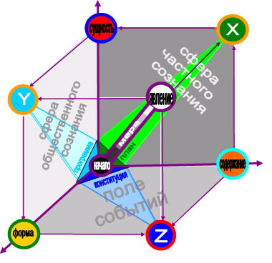
The standard model of information space-time in any state of the world must have a standard set of 7 clusters which correspond purposefully, for example, to 7 colours of the rainbow, to 7 music notes, to 7 people’s organs of sense.
Thus, every of 7 clusters has its own flow, for example, visual, auditory or other information, so have its own frequency characteristics, its own installation-specific-settings, its own measuring unit, and etc. Exactly this fact, being ignored by «the God», allows at physical and mathematical level to describe sufficiently the condition and dynamics of all legal phenomena and processes with the use of an arsenal of modern means and methods such as spectral, mathematical, holographic, aesthetic and other types of analyses and expert investigations.
In general we speak about getting the practical decision of the goal on mathematization of the Humanities and a necessity of its implementation in practice of the law enforcement.
We cannot deny that in the criminal world this model is called as the mechanism «the rules of underworld». It as religious, secular and class mechanism has been created for a hundred years but in contrast to them it is still functioning more effective and responsible both at the worldwide level and inside of different countries. The mechanism is based on the priority of the semantic basis that is substantial notions and natural principles (algorithms) which are identical for all people and in all languages. It should be noted that the determination of the class state as «coercion machinery» is vicious initially so has absolutely no prospects. Meanwhile the mechanism «the rules of underworld» of the criminals is only not civilized enough but possesses such exclusively important qualities as certainty of the structure, systems completeness and notions order (clusters) that is satisfies all main demands of integration and informatization (programming).
So it is necessary without any ambitions to understand and accept the fact that in the process of the modern civilization formation that is the development of Intellect criminals took participation more actively and efficiently than the majority of law-biding citizens. It is proved by appearing the worldwide crisis.
Probably in spite of getting constantly bad «lessons», destroying the life and losing freedom nevertheless criminals suffered, created and saved their mechanism «the rules of underworld» till the era of informatization. That is dialectics and nobody can deny so important gift of criminals used in the creation of the wold civilization bases of the third millennium.
Elimination of notions underdevelopment must become the meaning of future policy and practice in struggle against criminality. Though it is necessary to the maximum and carefully to save not only efficiency of the mechanism but romantic beauty of relations founded on the realized choice of risks, readiness to difficulties and protection of the honour, and etc.
Creation of the standard and unified basic clustering model of information space-time allowed started its adaptation in the subjects sphere and the creation of model lines classified according to purposes and defined functions (right, measurement, control, and etc.).
Thus in order to liquidate the above mentioned «generator» of the arrhythmia and negligence the noocentrical information model of the Universe structure has been developed.
The model is an information picture of the world where not the Earth (the geocentric model) and not the Sun (the heliocentric model), but the Person is the center, the beginning and the final aim of functioning of «alive» space-time bth as for the Universe and for the state in particular. Picture 2
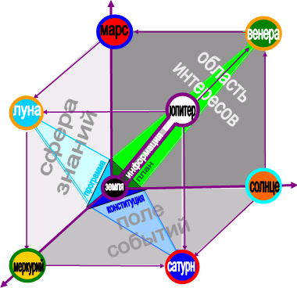
The noocentrical model of information space-time defines every person as the development end in itself that is the person is simultaneously a bearer, producer and consumer of information as well as a natural model and the universal measuring unit (in whole – the reference point) of space-time. That’s why the Constitutions of many countries take a person as the highest value of the state.
In order to implement the methods of spectral (Fourier) analysis into the sphere of the state authority and regulation the «colour-music» model of information space-time has been developed which is readable from music. Picture 3
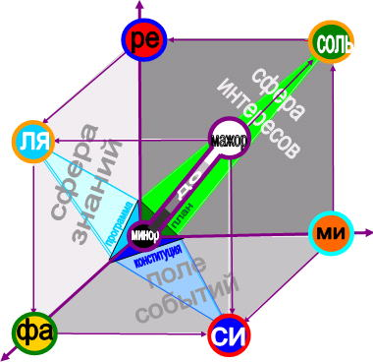
It should be noted that Pythagoras defined and solved this task in order to find a method which nowadays will allow revealing the level of harmony and beauty in the requirements of regulatory legal acts as well as the degree of their correspondence to the main algorithms of the Universe (universal values) and the Constitution «by ear», in light and «in colour».
Nowadays there are all premises and conditions for mass and practical solution of this Pythagoras’ task. Thus composers and colour-music settings have had a status for a long time and in Federal Republic of Germany the presentation of the Constitution as a music work has already done.
The greatest chemist and a founder of metrology, D.I. Mendeleyev, stated that «any science starts only if one starts to measure». Therefore the metrological model was created:
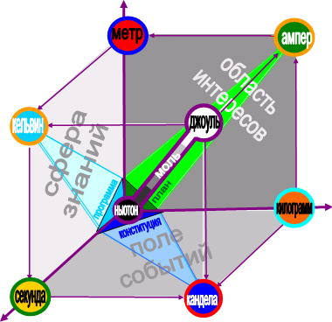
One carries out work on establishment of reference values pointed in the measuring units model and the creation of a programme which could ensure the observance of three main physical laws of preservation (mass, energy and impulse) and the action of ten principles of symmetry inside of the model in order to carry out the constant balance control with a range of ties and transitions of the goods into money, intellect into the goods, and etc.
The author explained the innovative potential of the information space-time models on basis of the law «a salty cucumber», which was formulated by some Novosebirsk scientists-physicians at the end of the 60th in last century.
Using the mega-method of the tensor space-time analysis and modeling the processes of two-way influence of elementary particles at the micro-level they made a universal macro-conclusion. Its practical meaning was defined as follows: «if a fresh cucumber gets into the tun with salty cucumbers it becomes salty too».
In other words, the mathematic algorithm was created which described the mechanism of dimension exchange, topological qualities and metric characteristics of two-unit (micro) and large (mega) spaces what made (macro) space accurately definite and controlled.
From the legal point of view this law is known to everyone as the postulate «a person is the whole set of public relations».
So we need to understand only one thing that people are born absolutely «fresh», clean and innocent but then the lose these signs and qualities because of exchange of dimension parameters, topological qualities and metric characteristics with a real «salty» external space-time (invoronment).
It will enable at last to stop eternal and stupid practice of search/establishment of legal templates for adults so we need to use as an etalon and an ideal of law the initial zero condition and new–born citizens’ natural behaviour who during up-bringing and staying in the society become those the society deserves.
The stated material allow using the «black-box» method for carring outthe control and the situation modeling on basis of data of statistic exchange and correlation of the Subject of law in information space-time (a state).
The result of these investigations was the creation of the mechanism of systematization and coincidence control on basis of legal statistics and special assessments.
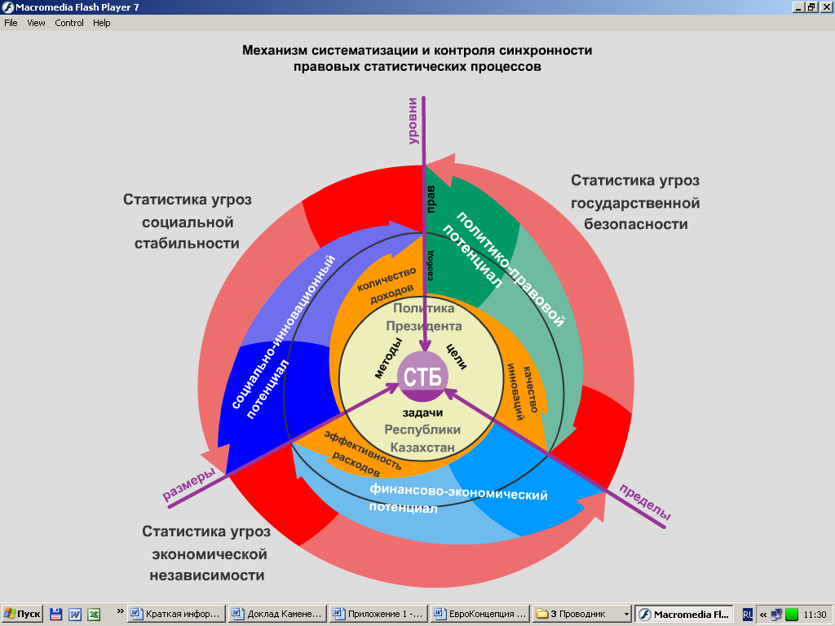

It allowed finding the task’s solution on mathematization of social sciences and as the result defining the technology of the state legal mechanism modeling on basis of natural norms and algorithms (the demands of the natural law but not the public law) priority.
The basic information space-time model became the basis for the creation of the absolute innovation in the form of the clustering model of information state and law (See next page)
The information legal statistic space-time model consists of 7 legal statistic clusters which include homogeneous information flows, foe example, from the position of the known doctrine on the crime (offence):
1. Orange flow – information about the subjects (the key question: Who?):
2. Red flow – information about the bodies protected by law (What?);
3. Yellow flow – information about places where crimes (offences) were committed (Where?);
4. Green flow – information about mental element (reasons and aims) of committed crimes (offences) (Why?);

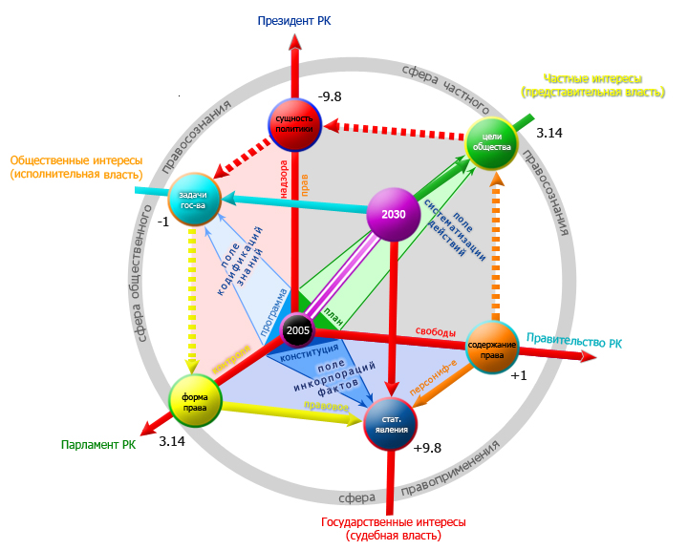

5. Blue flow – information about objective element (public danger) of the committed crimes (offences) (What for?);
6. Dark blue flow – information about methods and means of the committed crimes (offences) (How?);
7. Violet flow – information about the approved decisions and execution results on the crimes (offences) committed (When and Who?)
The application of the offered space-time method of events and processes’ description in figures format is only possible practical solution of the main task of modernization of any state authority and regulation system that is: the creation of the united integrated bank of information resources and legal statistic algorithms of the state which enables to provide consumers with information in the real time regime.
Thus it was defined that during the creation of state legal algorithms bank the possibilities of automatization of designing processes and the speed of managerial decisions output in the real time regime will increase.
In general even now we can say about the birth of the new information doctrine of the state and law as well as the cybernetic technology and the method of implementation of state-legal construction.
According to our data in the nearest future the existed technology of law-making and statistics conduct will be applied only for the «division» of the worst-case and special situations. New legislative demands will be introduced in computer programmes by pragmatists and collection of statistics dada will be automatically carried out in the framework of the «electronic government» net.
In the international law all states will be defined as relatively closed (independent) and autonomous self-directed (sovereign) space-time (organisms).
According to the modern space-time theory they will impartiallyhave three main signs: ecologically constant dimension, social topology (qualitative peculiarities) and econometric parameters (quantitative peculiarities). These signs will become a basis for division of competences of three branches of power and selection of two main regimes of the society functioning: interests’ disintegration (in the space the time vector goes anticlockwise) and the interests’ synthesis (anticlockwise).
There are reasons to suppose that at the first stage the space-time conception of the state-legal formation will become a cause of the «intellectual shock» from many people because the initial definitions and the interpretation principles are out of the standard perception and thinking.
Thus, for example, economists and financiers will find themselves in the situation when they have to master the method of 3D balance formation and 4D budgets on their basis under the total action of three preservation laws (energy, mass and impulse) in the space-time (state).
Besides, they will have to create a new budgetary mechanism based on the principles of plans and full-cost accounting coincidence (self-sufficiency, self-repayment and self-financing) of citizens’ lives. The insurance system will work for everybody and everyone except the newborn and the disabled.
The operating legislative base (law) will define both as the form of living and the method of people public conscience (intellect) self-actualization. So the Constitution will be interpreted as a core of people’s intellectual potential and the key algorithm of the definite legal statistic space-time (organism).
Law-making will become not more than one of the methods of formation or change as per the defined aims of dimension, topological qualities and metric characteristics of the legal statistic space-time, and etc.
Everywhere the automated information systems will be created which will enable to provide with the constant legal statistic control and maintainability in all range of the priority aims and goals defined by the President of the country. It will allow restructuring the operating state-legal mechanism «along the lines» of «universal values» fast and efficiently.
In backwards «from people to the authority» these AIS will provide exposure, improvement and implementation of the current state-legal and national and economic circulation of all positive manifestation of people’s intellectual potential that is to solve the goal of social innovative system (civil society) creation.
We suppose that in Kazakhstan this system will be under the control of RK President and function to execute Article 40 of the Constitution by him that is the function of the symbol and guarantee of rights and freedoms in the legal statistic space-time of the Republic of Kazakhstan.
According to our data the fact of the presentation of the results taken from the investigations made and the merits of the above stated space-time technology of the state-legal formation are able to become the cause of explosive multimedia effect in the world.
Its common sense and the existence of the strong base of analog decisions «from the God» will become the cause of optimism and creative enthusiasm creation in the society and will be in demand in many directions of the regime «public construction». This fact will allow in a short period of time:
- eliminating all obstacles for creation of full informatization and computerization and increasing radically the expenses efficiency in such a way as, for example, on the account of termination of vicious practice of creation of a great amount of departmental electronic systems (financial, customs, tax and other spaces);
- optimizing the state authority and regulation structure, creating the united space-time platform for development of the lines of integrated computer-based programmes of the electronic government, electronic law-making, electronic justice, and etc. on systems scientific (clustering) basis;
- increasing the efficiency and the quality of struggle against corruption, embezzlement and other crimes, and carrying out the constitutional supervision and the legal control in the state in the real-time regime; and etc. because of debureaucratization of the state-legal sphere
From the geopolitical point of view in the nearest future we can expect the appearance of the precedent and after that some official cancellations from the class doctrine of the state and law among the states all over the world. The new qualitative market of intellectual property will appear in the world and there will be a need in specialists who know the technology of the space-time modeling and state-legal formation.
Acceptance and assessment of the right regime of the new methodology implementation will enable the initiators to become partners in mastering new state-legal technologies and to get the highest possible benefit. We need only to unite our intellects, efforts and means.

4. Standard legal statistical clusters – a basis of integration of civil society and effective government
(The present section represents interpretation of the contents and the mathematical device stated in article of unknown authors about application of a method of the cluster analysis in archeology. Measures for definition of authors are accepted).
Implementation by the state of the functions, realization by physical and legal entities of the constitutional laws and freedom in practice represents continuous process of occurrence them in contact and interaction among themselves during which the considerable volume of legal statistical information and these special accounts collects.
For the purpose of detection of regularities, modeling of a situation and drawing up of forecasts for the future civil servants constantly and periodically according to established periods (monthly, etc.) collect this information, classify, analyze and take from it conclusions.
Thus, for justification of the purposes and problems of the following cycle of management, increase of efficiency and quality of administrative decisions, preparation and adaptation of shots, and as a whole for state legal mechanism functioning this information represents a starting intellectual platform and integrating kernel of legal consciousness of the people.
Traditionally these types of works make object and object of activity of bodies of the state statistics, obliged to provide with a way of the analysis and providing statistical information process of realization of political goals and legal problems of the state. Statistical databases always formed information basis for formation, execution and control of execution of legal policy of the state.
However the world statistical science and practice never had and still have standard no "the general denominator» owing to what in the different states bodies of statistics proved and provided realization of the different purposes and tasks. As a result in the world community the opinion «became dominating there is a lie, bald lie and statistics», the depolarized treatment of statistics and so-called traditional statistical thinking were created.
So, still all consider that the statistics, including legal, should investigate only quantitative party of the phenomena and processes. From the scientific point of view in the sphere of statistical activity fundamental principles of dialectic unity and a relativity of physically real world as a whole and politicians in particular were meaningly ignored. To please to politicians and for providing to itself quiet life of statistics eyelids were compelled to leave out of attention the major practical questions: concerning what standard, as well as by what technique it is necessary to define, estimate and measure quality of legal policy of the state? Meanwhile, in modern conditions of global information without the answer to these questions adoption of effective and qualitative administrative decisions is impossible.
For this reason historically process of intellectual evolution in the sphere of statistical activity and culture level (technologies and technicians) maintaining statistics always were in direct dependence on perception of its role and value political leaders and heads of bodies of the state, their replacement or change. Anyway, but still overcoming of elements of a traditionalism, conservatism and inertness in the sphere of statistics occurs on the basis of natural or compulsory rotation of generations of government officials.
In this plan basic feature of a modern situation in the Republic of Kazakhstan, is that subjective factors ceased to be defining and solving in development of national statistical system.
It is known that the domestic and foreign policy of the President of Republic of Kazakhstan N.A.Nazarbayev is directed on integration of the country into uniform world information and economic space, based on a priority of universal values and strategically focused on creation of the Eurasian (existential) model of the state.
In the methodological plan it gives unique opportunity for definition and a capture for a basis a conclusion that a determinant in the country is the interconnected complex of the objective requirements following from uniform and one global crisis of civilizations: the real state of environment, occurring information and need of introduction of system of universal values. Differently, a conclusion about existence of the situation demanding not a set of traditional and standard decisions, and one also it is system uniform, i.e. an integrated solution.
In this work search of such decision at the first stage was carried out by development of standard model of information streams in the Eurasian legal space time. The task fully was put to consider requirements and, moreover, in due time to bring adjustments in a configuration of the program of creation realized in the country of «the electronic government». Owing to this fact the main emphasis was made on methodology and technique creation application of all range modern natural-science (existential, information, etc.) and legal statistical methods.
According to the carried-out researches, observance of requirements of system of universal values should be provided in practice by a way of consecutive and strict realization (legal dictatorship) in the society of principles of relativity, a correctness and compliance of all administrative decisions to mathematics requirements. In this sense of the requirement of universal values and mathematics are identities.
As a whole it is established that observance of principles and requirements of mathematics should become the main method of providing a mode of legality in the state and justice in civil society, and also criterion of an assessment of efficiency of supervision and control of execution of universal values.
One of methods of the mathematical data processing, in this regard, the cluster analysis is useful. In the scientific and methodical plan the cluster analysis allows to determine topological properties (quality) and metric characteristics (statistics) of legal space time by identification and data processing by set of legal objects and processes. It allows to classify a set of objects, the phenomena and processes in legal space on classes close among themselves on properties and signs, and further, taking into account set of their statistical parameters, - to define structure and to diagnose at system level a legal situation as a whole.
Thus, under condition of observance of mathematical requirements of a correctness and sufficiency of data, the analysis revealed by statistical methods of "clots of objects", called by clusters (classes, taxon), allows to define logic model and vector structure of real legal space time.
Various types of the cluster analysis were actively applied and applied in a number of the modern states of the world as a uniform program and target and organizational and methodical basis of planning, first of all, economic development. Thus such countries as Finland, Singapore and others application of cluster technology define as a method, provided to their people modern wellbeing.
Simple example of realization of a cluster approach is, for example, classification and structurization of offenses by one sign or the basis taking into account statistical frequency of their commission. It allows to create look matrixes "object-sign-time", i.e. a technological basis for automation in processes of legal registration and classification.
Taking into account strategic prospect and inevitability of transfer of all state and legal and statistical world systems to the course of uniform requirements of universal values or, on terminology of the United Nations and OSCE, in a legal regime of «human measurement» developments of societies, the standard model of information legal statistical space of the country with a standard (universal) set of clusters is developed.
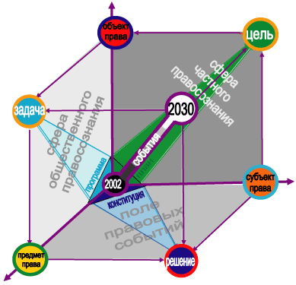
In dynamics the legal clusters found and used for the first time, after repeated collecting legal statistical information and application of the cluster analysis can "be scattered" owing to not stability (accident) of earlier revealed cluster structure. This destruction occurs when the legal space is homogeneous or in it the number of clusters not corresponding to reality was for the first time set not steady, i.e. In fact it means not compliance of clusters to legal statistical space (mode).
Reliability of existence of cluster structure is usually checked by attraction of the additional facts, classification research with use of variables, as participating, not participating in a clustering. Thus the main advantage of a clustery method as a whole is that real changes in practice of right application serve in all cases as the main criterion of an assessment, i.e. its controllability.
In this sense, for example, introduction of continuous and continuous monitoring (control, supervision) performances of the Law of Republic of Kazakhstan «About an order of consideration of addresses of physical and legal entities», will directly lead to creation in the country qualitatively new (not distorted on "entrance") systems of formation of information database of legal statistics and special accounts. Thus technological "secret" consists that the state bank of legal statistical information will be formed not by collecting reports from the bodies of the state interested in distortion, and directly and directly from the population for the purpose of measurement and an assessment of activity of work of bodies of the state.
Important circumstance is that from positions of legal statistics there is no need for each case or a temporary cycle to look for the solution of a problem of creation of clusters as the main algorithm and a geometrical vector of development of legal space time in the form of the Constitution of the country is sizes rather constant, i.e. change of structure of clusters and legal statistical model as a whole don't demand.
Theoretically there are two cluster approaches. The first starts with a hypothesis or a postulate on absence of cluster structure in a data file of legal statistics and special accounts. In this case distribution of the legal phenomena and the processes which have remained as a result of initial definition of legal statistical space time as homogeneous and standard set, i.e. as data "ideally bad for the cluster analysis" is studied. At work with real legal statistical data the analysis of residual dispersion is directed on hypothesis check about absence of legal cluster structure. Here it is possible to estimate, in essence, only efficiency classical (out of cluster) theories of legal statistics and special accounts as a whole.
The second cluster approach is more perspective as is dynamic and is based on use of a method of imitation repeated (periodic and cyclic) Boot Strap data collection (Efron, 1986). Thanks to this approach, it is possible to estimate both stability of classification as a whole, and stability of classes and separate objects in a leader layout on the set prospect of development. Application of this method was developed for research difficult, including organic and public structures (Rostovtsev, etc., 1994).
Among a set of methods of the cluster analysis with reference to legal statistics and special accounts it is necessary to consider only the methods, allowing to study big arrays of statistical data in a mode of sufficiency of random access memory of the COMPUTER. The procedures developed by Ball and the Hall, Makkuin, algorithm IZODATA belong to such methods (Durant, Odell, 1977).
Thus as the main postulate it is necessary to define that criterion of a clustering in the sphere of legal statistics and special accounts is achievement of a minimum of disorder of legal statistical information, i.e. finally, - providing information providing the decision in practice of a problem of integration of activity of system of state authorities and civil society (in mathematics – tasks on an extremum).
At definition of criterion of a clustering use of various quantitative values (metrics) on a set of objects of legal statistics, including being in a mode of change (transit) of the qualitative properties and quantitative parameters is possible. Thus multidimensionality of real legal space time and "curvature" of the legal consciousness, the legal entities who were in it, is overcome at the expense of direct action of the Constitution of the country which main advantage is system, continuous and simultaneous performance of three integrating functions:
а) attractions, including by coercion by the state, all political masses and forces to intellectual epicenter in the form of system of strategic objectives and the current tasks, organizational principles, rules of law and methodical requirements;
б) the main algorithm of development in the set legal statistical space time in which program and target structure of indicators and parameters of development (control) are defined on the basis of the long-term Strategy-2030 program, and in the current mode on the basis of Strategy of achievement of the European standards;
в) strictly certain geometrical vector or, otherwise, political direction of development of civil society (contents) and state (form).
Such treatment of legal statistical space time as a whole, and also an organizational and methodical role and practical value of legal statistical clusters for country development with guarantee provides legal statistical control concerning the Constitution, moreover, contains the mechanism of purposeful decrease in disorder of legal statistical data and, thus, stimulating timely acceptance of these or those measures for protection of a mode of legality.
In practice it, as a rule, becomes by development and the mathematical analysis of the determined co- variation matrix (Petrovitch, Davidovich, 1989).
Almost ideal conditions for creation of such matrix in the sphere of legal statistics and special accounts are provided, in particular, by the order of Head of state N.A.Nazarbayev given in one of Messages to the people, about development of Strategy of achievement of the European standards in economic and social spheres.
The stated is considered when developing the Technological card of information legal statistical support bodies of the state, physical and legal entities about a legality and law and order condition to the Republic of Kazakhstan.
The technological card starts with mathematical definition of legal statistical space time at the same time Euclidean and bent Riemannian for which a mathematical standard (the development purpose) is well-known in mathematics the "ideal" space time of Minkovsky (1914).
As a whole it is a question of a method of creation of ideal model of legal space time (state) and extrapolation of its system structure of clusters, i.e. statistics and the parameters known in a legal science as norms of the natural right, to the existing "bent" legal reality. Thus we will note that in the methodological plan and in mathematical statement of a task this approach isn't new.
For correct application it in the state and legal sphere is necessary to start with a postulate of definiteness of Strategy of development as a whole, i.e. that d - Euclidean distance between two vectors which have been set in a time interval from 2004 (the initial description is given in the Message to the people from March 19 of this year) and till 2030. (Strategy-2030).
The matrix of the purposes developed on this basis and problems of legal statistics and special accounts represents a matrix of the object-sign-time type [Xij], i=1..., m, j=1..., n, where i - object number (for example, groups of the homogeneous crimes recognized official), j - sign number (for example, corruption), matrix elements – quantitative values of signs. Thus, objects { } are described by Xi as a line of a matrix of data.
Let there is a splitting of set of legal statistical objects into k of classes (dynamic ranks and their groups)
R={R1,...,Rk}; R  {1,...,m}; l = 1, ..., k.
The general square-law variability of data of legal statistics and special accounts is determined by homogeneous set of objects by a formula
SST = 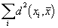, (7.1)
Where - the constitutional epicenter of weight of all objects (an average arithmetic the corresponding vectors).
The size SST/m represents the generalized dispersion of multidimensional data of legal statistics and special accounts.
The interclass disorder of parameters is characterized by an indicator
SSQ(R) = , (2)
where l - Rl center of gravity.
The size SSQ (R)/m represents an assessment of residual dispersion at a disorder explanation R classification.
Direct use of SSQ (R) is inconvenient for the description of quality of classification as this size depends on initial level of variability of data of SST. It is much more convenient to apply a share of residual dispersion:
Q(R)= 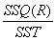. (3)
The share of the explained dispersion can be used also:
T(R) = 1 - Q(R). (4)

5. Strategy – 2030 as a basis of a clustering of data of legal statistics and special accounts
Strategy-2030 is the main program and target document regulating development of the Republic of Kazakhstan on rather long prospect. Owing to this fact she allows on a constant basis, without losing track of ultimate goals, consistently to carry out splitting of set of legal statistical objects of R (2), R (3)..., R (k) on two, three and more classes. At creation of splittings initial splitting which "improves" in a way described below at the expense of moving of objects from a class in a class is used.
At creation of R (k) objects of Xi, i=1 are serially considered..., m; for each of them the size DSSQ is calculated (R, i, l) SSQ (R) reduction at transfer of this object in a class l of splitting of R (k), thus is such class l (i) for which the size DSSQ (R, i, l) is maximum. The object is transferred to the "best" class l (i) found for it if thus there is a criterion improvement, and not transferred otherwise. After viewing of all objects process repeats. Work of algorithm stops, if at the next iteration there is no criterion improvement.
As initial splitting of R (2) = { R1, R2 } undertakes splitting { { all set of objects }, { an empty set } }.
As initial splitting of R (k) = { R1..., Rk } is considered splitting of R (k-1) with the empty class Rk attached to it.
In essence this algorithm is updating of known algorithm "k of averages" which also is the local and optimum algorithm minimizing Q (R). This algorithm consists in the following:
1) k of objects - the centers of clusters casually get out;
2) each object belongs to a cluster, distance to which center minimum;
3) the new centers of clusters - averages arithmetic on their objects are calculated;
4) if at least one object moved to other cluster - transition to item 1 is carried out), otherwise the algorithm finishes the work.
Let's notice that in optimum classification the algorithm of k of averages won't carry out moving of objects.
Assessment of the importance of clustery structure on the basis of a hypothesis of ideally bad data
The first of studied approaches is based on the statistical hypothesis, consisting that data represent sample of multidimensional normal set with an individual covariance matrix (data are ideally bad). Such data represent onecluster structure and clusters in it are formed only in a random way.
For the clustery analysis, in view of complexity of legal algorithms, it is important to have necessary the statistical number of data expressing function of distribution of an assessment of quality of a clustering (residual dispersion, for example, crime). In this case there is the unique way - a direct assessment of distribution on a functional of quality of a clustering, i.e. by carrying out numerous experiments on casual samples of "ideally bad" set for a clustering.
For comparability of real data with look-ahead transformation of data to the spherical cloud corresponding to data, having an individual covariance matrix is necessary.
Such standardization of data is carried out quite simply: it is enough to use the algorithm of the factorial analysis giving orthogonal factors. Values of factorial estimates on objects also will be the standardized data. It is possible to consider also and other methods of standardization connected with nonlinear structure of an arrangement of data (Кruskal, 1964).
Further the received results will be applied to the standardized data.
The main condition of application of a cluster method is standardization of empirical data, carrying out big volume of computing work and creation of individual tables for each algorithm.
Use of results of research for rather big dimensions of data is on the verge of computing possibilities of the usual software.

6. About efficiency and feasibility of researches’ results today
For the purpose of demonstration of efficiency and practical feasibility of the received results of researches I developed the draft of the Concept of antikoruptsionny model not having analogs, technological and technical modernization of system of criminal prosecution and justice (further – the Concept).
The draft of the Concept provides introduction in the sphere of criminal prosecution and justice of the uniform standard and unified system of the legal statistical coordinates corresponding to standard and unified requirements of universal values.
Practical task of the Concept is creation of the integrated state bank of standards of the natural right and legal statistical algorithms which would provide information and automation of criminal trial and justice within Strategy requirements "Kazakhstan-2030" and RK Constitutions.
Now the postulate «the world is ruled by information» is an axiom which is not demanding proofs.
However conclusions and advantages from this axiom while ideologists and organizers of transnational types of crime, such as take only terrorism, extremism, corruption, drug addiction, etc. Widely and legally using possibilities of modern global networks (Internet), television and mass media they already created and actively maintain some kind of industrial and information mechanism based on mass use of intellectual imperfection and moral defects of people: political scepticism, legal nihilism, scientific ignorance, mercenary and low qualities.
Bright example is practice made in a number of the countries of «color revolutions», i.e. application of a method of remote control by sense of justice and behavior of people for the solution of anticonstitutional mercenary and corruption tasks.
In the technical plan it is a question of ability of criminals is system to plan and «to operate the end results» on the basis of technology of cluster control of flows of information, i.e. dimension parameters (balance of forces), topological (qualitative) properties and metric (quantitative) characteristics of legal information space time of the sovereign states. Certainly, taking into account data on real level of technological and technical armament (backwardness) of law enforcement agencies of the state, intellectual potential of their workers, mobility of systems of resource providing, etc.
The general analysis of the countries victims of «color revolutions» testifies that their national statistical systems had no mechanism of control and quality management of legal space. In particular, it was not kept account and level of organizational losses, i.e. losses and not received income as a result of unsystematic character, chaos and not efficiency of work of bodies of the state, physical and legal entities wasn't defined.
As a result law enforcement agencies of the majority of the countries of the world still position themselves and are guided by defensive doctrines of fight against crime, can't come off traditional paper technologies and aren't capable to neutralize operation of the criminal mechanism of solution of problems and problems of affairs «on concepts» and by a rule "the end justifies the means".
Data that in the conditions of sharp growth of dynamism in the sphere of legal relationship official recognition by the uniform unified, system and priority legal priority of the state observance of requirements of the procedural legislation, i.e. a legal regime of realization by bodies of the state, physical and legal entities of the rights and freedoms, economic interests, etc. should become the first step are obtained.
From the practical point of view to law enforcement agencies from now on follows not only and not so much rigidly to stop quite legal requirement to improve, say, political system of the state or quite natural desire in market conditions of government officials to be rich, how many and exclusively to provide control and use of lawful forms by all and methods of the solution of such tasks.
Establishment of a priority of standards of the procedural legislation (for example, or GPK KR) over norms of a substantive law (UK or RK Group) will allow to overcome the Criminal Procedure Code static stereotypes (dogmas) and to eliminate basis of domination in state and legal sphere of formal and bureaucratic (paper) technologies with positions «state – is the coercion car», to increase quality, flexibility and efficiency of adoption of administrative decisions at the expense of consecutive algorithmization of legal processes, etc. Formation in the country of a preventive (anticipatory) legal regime of fight against crime, and also uniform information system of counteraction to external and internal sources of illegal impact on sense of justice (behavior) of citizens will be a result.
From the stated the major methodological conclusion follows: in modern conditions a support and a priority of law enforcement agencies on power (not intellectual and not information) methods of fight are a powerful destabilizing factor, conduct to concentration of illegal potential and crime self-reproduction.
Thus productivity of «color revolutions» and called types of crimes testify to a high probability of growth of "orders" for application of illegal information technologies as from external, and internal interested persons. Besides, it is necessary to expect effect of corruption integration of the last on the triune political, economic and criminal platform, i.e. consolidation of oppositional, destructive and criminal components for the purpose of the general exit to qualitatively new technological level.
Thus, the complex of the preventive system and radical measures excluding possibility of a manipulation by public and legal consciousness of citizens of Kazakhstan is necessary. A practical form of the solution of a task is emergency technological and technical modernization of activity of law enforcement agencies, at this stage, by development and introduction within a network of «the electronic government» program complex with a configuration of uniform and indivisible legal statistical space time of the Republic of Kazakhstan.
The most important purpose of a telecommunication network created in the country of «the electronic government» is creation of system of information service. Continuous legal statistical monitoring of a condition of legality and a law and order in the country and the mechanism of program and target support of activity of bodies of the state, physical and legal entities will be its major components.
In this plan the perspective project is creation and introduction in practice of public prosecutor's supervision of the automated information system (a program complex), capable (го) in a mode of actual legal statistical space time to provide control of execution of norms of UK RK, and also to optimize and synchronize interaction of subjects of criminal trial within requirements of the Criminal Procedure Code of RK.
Earlier in the conditions of exclusive domination of technologies of paper flow of documents channelized long it was investigated as a planning problem at stages of criminal trial. The set of works and dissertations is published. However with the advent of electronic technologies such terms as «algorithm of criminal trial» began to prevail and, respectively, to decide a task of «algorithmization of criminal trial». Owing to this fact, for example, on the Internet hundreds sites respond to search of these keywords.
Now the method of identification of events and processes in real legal space time, etc. aren't used the multidimensional (existential) solution of a task on the basis of a cluster approach.
In this plan the main innovative solutions of the project (in the future – a program kernel) are:
- creation of an electronic copy (virtual model) real legal statistical space time;

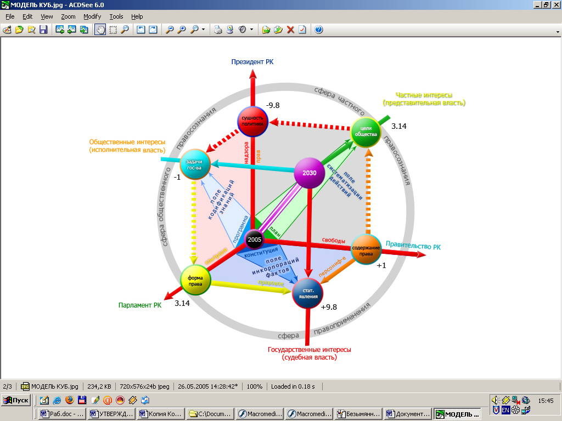

- application of a method of geometrical identification in space time of rules of law, statistical events and processes on the basis of a postulate: the correct (legal) decisions represent geometrically correct (ideal) figures and, on the contrary, everything is exclusive not the correct (illegal) decisions have geometrically wrong form.

А) model not legal decision B) model of the legal decision
or behavior or behavior
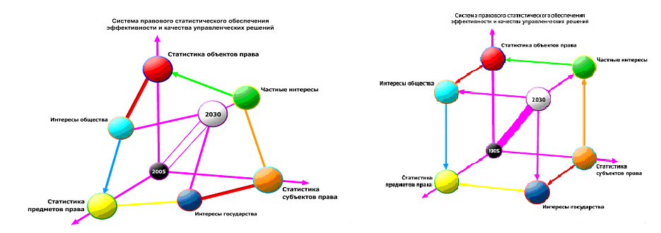
The method of geometrical identification will allow to solve a problem of creation of the computer program on qualitatively new basis, a technological kernel and a core (as a whole - a platform) which will be uniform for all bodies of the state, physical and legal entities system of legal statistical coordinates with the algorithm (mechanism) providing focusing effect in their joint activity at all levels of interaction and on a national scale.
Thus support of system of coordinates and its information base in the actual condition identical to real legal space and statistical time, will be carried out by two methods:
- acceptances by the President of RK of the regulatory legal acts defining and changing three main signs of any space time, i.e. dimension, topological (qualitative) properties and metric (quantitative) characteristics. For this purpose there are special manufacturing techniques in singular of the interface (panel), allowing to define, change and supplement (as a whole - to operate) dimension, topology and a metrics of electronic legal statistical space time of the Republic of Kazakhstan with high and guaranteed extent of protection against illegal access;
- continuous updating in system («the electronic government») the legal and other statistical information received from Subjects in response to Laws RK «About statistics», «About the state legal statistics and special accounts», and also as a result of monitoring of addresses of physical and legal entities. Besides, at the expense of the data received in the area of the state registration, statistical and other executive bodies, on structure and dynamics, specifics of tax, price and other real legal statistical conditions of realization by citizens of the rights and freedoms in concrete regions and about the country as a whole.
At this stage practical realization of the called innovations at the same time in the sphere of foreign economic relations and customs control, and also in the internal direction - in the sphere of criminal and criminal and procedural legal relationship is expedient. In these spheres most sharply there are problems of providing constitutional laws and freedoms of citizens, fight against corruption, etc., that precedent of system integration of databases of customs (external) control not having in world practice and public prosecutor's (internal) supervision, and also the mechanism of continuous information support will allow Kazakhstan to create:
а) at system strategic level - long-term Strategy «Kazakhstan – 2030» and the existing Constitution of RK;
b) at operational and tactical level – the current legislation and annual Messages to the people of the President of RK;
c) at local level – all range allocated in the legislation and standard for legal statistics and the special accounting of functions of the state, such as criminal law and criminal trial, civil law and civil process, etc.
The author designed the technological scheme which is structurally consisting of three independent contours, reflecting movement of three diverse (by the managing director, staticizing and user) of flows of legal statistical information. (see fig. 7)

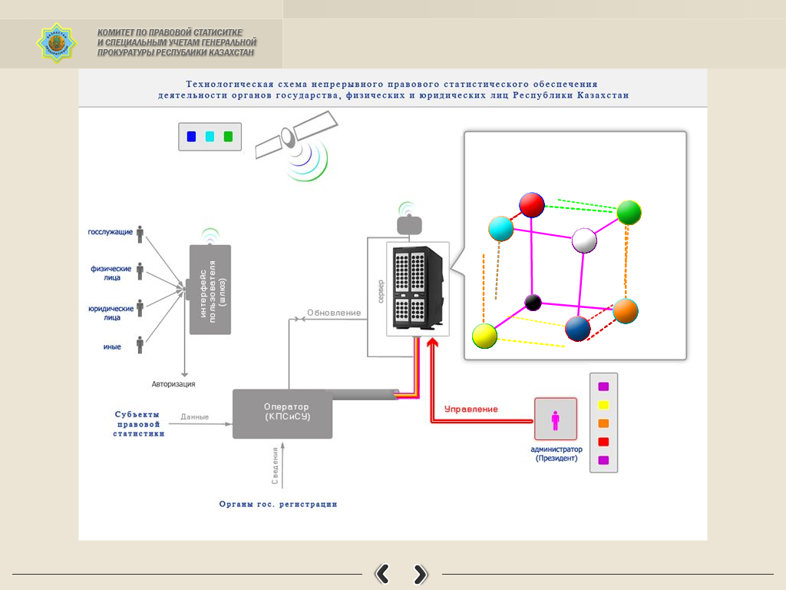

The basis of the technological scheme is made with that during realization of any global, economic and private tasks, legal and not legal decisions three types of the resources having, respectively, three absolutely different systems of measurement participate: human, material and financial. In compliance with these measurements information streams were classified, systematized and synchronized in physically uniform system of legal statistical coordinates. (see fig. 8)

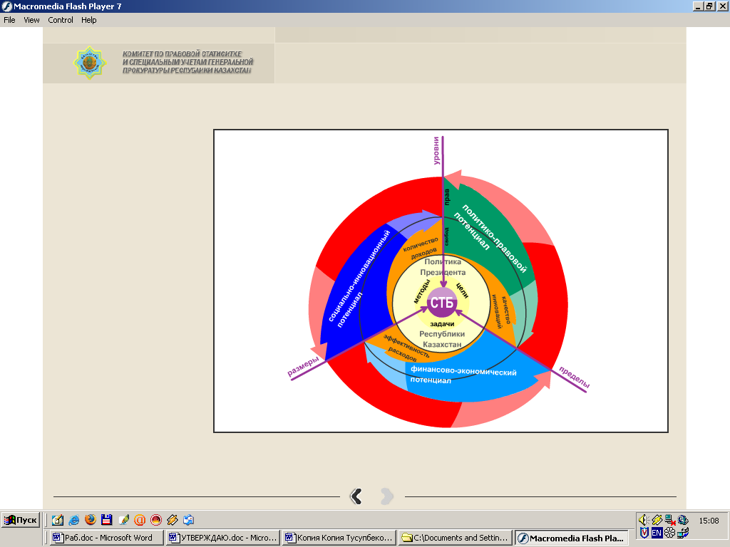

As a whole it is offered first to put into practice a method of creation of the general and uniform country for all users, including - civil servants, invariable system of legal statistical coordinates with the built-in vectors of the Constitution, specific goals, tasks etc.
Thus for users three of 7 legal statistical clusters of the electronic space time, allowing to define the purpose (a green cluster) will be active only, to put tasks (a blue cluster) and to choose methods (a dark blue cluster). Other 4 clusters will be available only in a mode «to reading», i.e. to carry out concerning intentions of users function of system of coordinates for definition in it, the account and control of legal statistical events and processes from positions of «the legal environment».
The clustering of information streams allowed to allocate correctly at modeling electronic level real and virtual information streams, and the main thing in a mode of natural (spectral) compatibility to involve on one server with a program configuration of uniform legal statistical space time, with the general bank of control legal statistical standards and continuously updated base of legal statistical information. Respectively, the operating system should have three functionally different interfaces (panel).
From positions of users the program complex will represent the legal statistical "lock" allowing them to prove the purposes, tasks and methods, to identify them with legislation requirements (the legal environment), to bring into a due "electronic" format, to contact and carry out interaction with the state in a mode of «the electronic government».
On a range of carried-out functions and provided services the developed interface (panel) of the user should serve as at the same time electronic legal statistical "office", "expert-adviser" and state "reception" as one and uniform Subject of legal relationship cooperating with physical and legal entities in three main technological modes:
- in a standard mode of Subjects of legal relationship equal in rights when the state as the partner has the identical civil-law status with legislative physical and legal entities;
- in a mode of the special accounting of Subjects of legal relationship when the state has the administrative legal status based on the right of the state to apply concerning not legislative physical and legal entities of a measure of compulsory character to carry out functions of supervising, supervising and punishing body;
- in a mode of using of civil servants for which input of the personified electronic identification codes with centrally set directly in the server program depth of immersion in bank of legal statistical information, and also defining a range and a range of subjects to providing data according to their legal status, powers of office, the admission to secrets etc. is provided.
So, primary registration of a legal statistical event will be accompanied by automatic assignment of number (code) and opening in a "box" database for storage-maintaining-supervision in it corresponding «electronic business». Irrespective of the fact which it: criminal, civil, administrative or any another. Important that business as the electronic copy of the paper version, will have the built-in mechanisms of temporary criminal and procedural, substantial and formal control deducing results on the display of officials, having the right of access (the inspector, the prosecutor, etc.). Thus, for example, the inspector will form electronic business, but only without the right to take out or change («marafetit») documents whereas the supervising prosecutor will have possibility to check business only in a mode for "reading" with the right of the subsequent reaction.
Advantage of the centralized identification is fixing (maintaining the account and control) entries of officials into contact and possibility of performance by them the duties from any computer in a network and the cell phone.
With a view of ensuring effective and high-quality work of information system «electronic supervision» it is necessary to create the special interface for employees of bodies of prosecutor's office and the legal statistics, having algorithm of control of procedural terms and the corresponding forms of reaction.
Here it should be noted that the organizational and methodical basis of a program complex is made the model of a choice standard in a science and adoptions of administrative decisions, and also by a principle of a priority of preventive activity of bodies of prosecutor's office, i.e. prevention and prevention of offenses.
Therefore the program should provide a wide range of informing, analyzing, modeling, predicting and other services only and exclusively with a view of acceptance by users of effective and qualitative legal decisions.
Differently, the general configuration of the program and the technological solution of the developed operating system are directed on elimination in law-enforcement practice of the situation which diagnosis was put by the founder of the theory of systems and integral calculus G. Leibniz: «errors of the majority of people – are result of an ambiguity of words and aimlessness of their experiences».
According to our data, analogs of the positive solution of legal statistical tasks in similar statement and by creation of the general for all Legal entities of uniform state system of legal statistical coordinates at present in the world aren't available. Moreover, it is authentically established, what exactly it is the main deterrent for creation, including - in the developed states of the world, the full and complete version of «the electronic government».
The developed program practically solves a problem of "focusing" of activity of bodies of the state, put by the Head of state at meeting on questions of administrative reform from September 17, 2004. Thus offered innovations aren't beyond requirements of the current legislation regulating activity of state authorities.
At the same time, these innovations have big practical value as in consciousness of users uncertainty of the maintenance of ultimate goals of the state and, as a result, a formalism in a field of activity of law enforcement and statistical agencies is eliminated. As a whole the cluster approach will allow to structure, systematize and optimize information streams of legal statistical space time, to apply methods of volume modeling, the analysis and forecasting of legal development of civil society with target information and methodical support, continuous legal supervision and statistical control.
The program will be universal in domestic and global levels, as it is based on the new method of the identification of geometric and mathematical processing (tensor analysis and optimization) of legal cases and statistical processes. The main feature of the mechanism of the program (method) is that it is on the strict natural-scientific basis, converts the content of the goals, objectives and methods (in general - the interests) of the state, individuals and legal entities in the geometric form (shape), who have their vectors of development in a legal statistical space-time.
On the computer monitor the program will in volume and dynamic visualize the (make visible) legal statistical information, inasmuch all legal statistical figures-events and vectors-processes in a strictly defined extent coincide or not with the parameters of legal standards, the vectors of the human values system​​ (global and strategic level of use) and the Constitution of a country (internal operational and tactical level), also have different structural and dynamic parameters - speed, power, inertia, and other (private level).
Making a server program based on the method of geometric (space and time) identification of legal-statistical cases and processes, on the one hand - immediately tackle the problem of difference, for example, state and national languages in Kazakhstan, i.e. solve the problem of their compatibility with the electronic "language" of the computers on the universal semantic (mathematical) basis. On the other hand, - provides an opportunity based on a single server with built-in software configuration of the legal statistical space-time to carry out any operations related to addition and subtraction of vectors, or figures, the construction of dynamic series, modeling, forecasting and optimization in the space-time , geometric visualization of the legal statistics data, etc.
The developed method of the geometric identification has deep historical roots, inasmuch arises from the ancient philosophical and scientific definitions that "geometry - is the science of politics" and "the world – is a harmony of numbers" (Pythagoras). In the modern interpretation, this approach allowed us to classify as geometric objects and visualize in the electronic legal statistical space-time of the state events and processes through the implementation in computer program the following physical and technical postulate:
According to the law, all Subjects of law, before doing anything, are obliged to think, that is, to analyze the situation, ground and take only legal decisions. Objectively, their decisions may have legal significance at three levels: international, domestic and private levels. During the implementation in practice the decisions take forms of real events and processes, i.e. volume and multi-dimensional geometric figures with the vector trajectory movement. This makes possible the elaboration of computer programs focused on the creation and use of artificial, in this case - the legal intellect with a built-in bank of natural legal (geometric) standards and algorithms of identification.
At the present moment the Republic of Kazakhstan has the full range of legal, electronic technological and technical solutions to begin the creation of their own "electronic government" which also do not have analogues of the Eurasian (space-time) legal statistical system.
However, it should be remembered that in accordance with the principle of self-sufficiency of the system launching a program into practice cannot be carried out without the derivation of quantitative values of the bank's legal statistical information on the level of the mathematical law of large numbers and probability theory.

7. Issue of the day, new forms and implementation methods of coordination functions by government to protect the rights and freedom of citizens
In summer of 2008 in St. Petersburg at the 8th Conference held with the participation of 41 Attorney General of the European countries and 12 international organizations, the Commissioner of the Council of Europe for Human Rights T. Hammarberg gave a report: "The Office of public Prosecutor is the support of the democratic state."
Undoubtedly the event is a landmark and evidence of the coming qualitative shift in the global practice of the state legal construction, in the practice of modernization and efficiency of existing systems of state power and government.
At the present moment among the existing leaders only the President of the Republic of Kazakhstan Nursultan Nazarbayev is guided by inference of strong significance of the prosecution under global crisis situations. Moreover, he took a decision at the system level, to assign them a coordinating function in the system of government and law enforcement.
Actually, the Head of State defined in a new way the practical sense, prospects of development and the main organizational and methodical algorithm for modernization of the prosecution activity. Simply speaking, he demanded to consider in the future the public prosecutor's supervision, not as an end in itself and the final result of a work, but as a preparatory stage, allowing to realize the collection of information for the next realization of its primary function in the system of state power and government, namely the coordination of government organs, individuals and legal entities.
Figuratively speaking, the Head of State not only reminded the prosecutors well-known definition of the prosecution as a "sovereign eye", but also demanded to realize the practical meaning of the proverb «so near and yet so far". Also I mention, delicately and tactfully on the expectation of the ability of prosecutors independently and accurately draw conclusions.
Thus, the problem of conducting an effective supervision activity is remained by prosecutor organs, but now it should not be the final end in itself and supervision must be an active instrument of creation.
At the same time the goal of coordination and accordingly the task of the prosecution must be the provision of synchronicity and harmony in the development of states, in the process of implementation of the legal entities at all levels of activities of an anti-crisis plan. At the same time the main criterion for the realization of coordinating role in one regions or another should be a change in the data of statistical monitoring of legal protection and restoration of rights.
The information is in close agreement with the main content and trend of the modern world community’s activity is to find effective forms and practical methods of overcoming the global financial crisis.
At the same time humanity has only supposed the generally recognized «diagnosis" that one of the basic postulates of the former financial policies and practices of the USA about “self-regulation" of the market economy was wrong.
Most countries in the world only reveal the consequences of their self-removal from the management of economic development and at best, they are working to create a legal mechanism fulfillment of supervisions, controlling, registration and records, and finally, the regulatory functions in the sphere of financial relations.
In general, an ant crisis operation in the world and within individual states is clearly characterized by unsystematic and uncontrolled feature. All countries and groups of countries, transnational industrial, financial and other corporations, moreover, the natural and legal persons are working out by their own individual methods and implementing the "own" anti-crisis plans.
Today the situation on the planet is clearly unnatural, and recalls, figuratively speaking, a huge self-service supermarket, where all buyers and sellers in the person of people, legal and natural person are guided exceptionally by their own ideas about everything, each has its own standards, units and measurement tools (scales, meters, etc.) and guided by a personal assessment method of any mental, labor and the mass of the goods.
Meanwhile, ignoring the requirements of consistency and unity in overcoming the global crisis leads directly to the growth of chaos and loss in geometric progression. There is clearly need for the elaboration, implementation and monitoring at the geopolitical level of one and the same for all subjects of international law model, uniform and obligatory global anti-crisis plan.
At the same time it is beyond question the expedient of creating a special global information system of support, which would be on the basis of a "matryoshka, nested doll" and of a program allow to keep in the planet count of the unified statistical reckoning, single metrological control and an electronic public prosecutor's supervision (integrated legal monitoring), realization of goals, objectives and requirements of the global anti-crisis plan.
The information shows that the consciousness of the modern politicians and scientists has become dominated by legal and statistical perception of the global crisis as a mass violation not so much of constitutional norms on the rights within the State as natural rights and freedoms of the majority of people in the planet.
It is established, the main reason of the global financial crisis is a century-old cult of money, accompanied by a complete disregard for the strategic goals of human development and by the terminology of the UN and the OSCE, the requirements of the "human dimension". At the same time the major terms of the cult of money were not the transparency of the movement of money and closure of information about the money attribute.
Analysis of opportunities of the global informatization and the internal network of "electronic government", carried out with a new coordinating and advocacy positions of the prosecution, showed that the reveal and suppression of facts disregarding the strategic goals of human development, also violations of the requirements of the "human dimension" at this stage can be carried out in automatic mode.
For that it should create the software, with the property of do not respond to law-abiding behavior and vice versa, to respond only to the facts of the unlawful (violations of the order, limits and access rules), as well as allowing the "electronic" way to solve technically the problem of ensuring the transparency and data protection.
The Republic of Kazakhstan has all political and legal conditions and technical presuppositions, necessary to start the creation work of such program. Thus, the external and internal policy of the Republic of Kazakhstan, as in no other country in the world is "tied" to the system model and the uniformed requirements of universal values​​, as show the set of geopolitical initiatives of resident Nursultan Nazarbayev, as well as goals and objectives of the long-term Strategy "Kazakhstan - 2030".
The system of government and administration has certainty on the strategic and innovative development prospects. 15 years ago the head of State set the task of creating the Eurasian model of an information state, which is based on the definition of the state as a "living space constitution," by the founder of the geopolitics science F.Ratzel in 1847.
The country has adopted a special Act of the Republic of Kazakhstan "On state legal statistics and special accounts", which regulates the collection processing, elaboration and granting to users - government bodies, individuals and legal entities of a reliable legal and statistical information to take them effective legal decisions.
Thus, the prosecution authorities of Kazakhstan have a model and a unified technology foundation for elaborating not only effective domestic plan but also global anti-crisis plan, as well as information infrastructure to create a system of legal and statistical support and "e-Public Prosecutions".
Moreover, methodological and scientific researches were carried out, which even now allow to refuse the prevailing vicious and civilized legal doctrine in the world based on Marx's class definition of the state as "machine of coercion."
Thus, the major streams (clusters) of legal statistic information were assigned, on the basis of methods of legal cybernetics and within the framework of sustainable physical model. As a result it is created a typical and uniform (basic) cluster model of the information legal and statistical space-time of a sovereign state. It doesn’t have analogues in the world of science and practice.
Using the cluster model for the elaboration of global anti-crisis plan and the creation of a global information system of legal statistical support allows you to:
- to cover the global information space-time in general, and mark out the statistical "nested doll", corresponding to three levels of objectively necessary legal supervision and control: the universal (global), special (within the State) and specific (private);
- to create a typical, uniform and standard, and most importantly, integrated software with the ultimate goal (function) of the smooth, full and responsible information to all categories, types and levels of the subjects of international law on the implementation of the requirements of the global anti-crisis plan;
- to create in a global electronic communications network a special segment with a highly accurate statistical information resource that is actualized continuously and guaranteed for quality content.
The validity of this global project is more than obvious and sufficient for the initiation of the Republic of Kazakhstan at the geopolitical level.
However, the main objective here is to create an electronic Bank of normative and legal algorithms that are functionally capable to provide on a national scale (single region), the continuous formation and visualization of real legal time data of the legal statistics and special accounts.
This allows applying the well-known method in mathematics, the method of constructing an ideal model and extrapolation of the ideal parameters to the model and the statistical indicators of a real law enforcement practice.
In the case of setting the technology of continuous forming of the legal statistics and special accounts in real time, it will be possible at any moment to compare actual figures and proportions with the indicators and proportions of the ideal Legal statistical model thus, to control visually the level of coordination (synchronicity) in the work of public authorities.
Unfortunately, the term legal algorithm is relatively new, clear and consciously used only in a narrow circle of scientists and programmers. Therefore, in the first stage the skill will be an important, as V.I.Lenin said in his time «to draw the moral" and create legal algorithms from the vast number of folk wisdom: proverbs, sayings, parables, religious exhortations, instructions, etc.
It would be better to know that the folk wisdom formed in the public consciousness of the peoples for thousands of years, due to the fact they are model, standardized, and most importantly are understood and widely used by most modern people in the course of communication. Of course, in the first place it will be necessary to collect the legal algorithms for the implementation at a system-level of organizing, regulating and coordinating functions.
For example, all the nations of the world have a huge number of wisdom about money and the rules of wise spending the money. Thus, actually all of the Kazakhs believe that "money is dirt of the hands" and also are convinced of Russian wisdom "money cannot buy happiness".
In this regard, the invaluable point of drawing the lessons of public morality belongs to the long historical experience of the USA to achieve strategic goals by implementing the "doctrine of conquering the world through the dollar," approved in 1911 by the USA President Taft. Experience is useful both in terms of a mechanism to achieve the strategic goal and vice versa, as an example of the vicious use of "naked" monetary base.
In the politico-organizational aspect the experience allows us to focus attention on and draw conclusions from the fact that in particular it is the cult of money and ignoring in the doctrine of semantic content (meaning) in the development of civil societies has created a crisis of modern financial systems of the world, now it is the main geopolitical generator of a crisis phenomenon.
In legal terms, the use of the experience of the Soviet Union in 1936 is no less productive, when the Head Office of Measures and Weight (now the State Standard) was transferred to the People's Commissariat of Internal Affairs. It is known historically that this unconventional decision allowed Stalin to ensure quickly and effectively the unity of the country's standards, methods and measuring instruments, curb the crime and make the ruble gold, etc.
Apparently, particular value of the USSR experience is a legal method at the same time, practical provision of an emergency mobilization and involvement in active national economic turnover of all intellectual potential of people. Undoubtedly, only the simultaneous use of such powerful, plain and multiplying the political impulse, as well as non-standard legal method is capable to provide Kazakhstan intellectual and technological breakthrough in the future.
It should be noted that Kazakhstan has favorable situations for this, because only in the part of the prosecution authorities of Kazakhstan it is operated a plenipotentiary body exercising on a regular legislative basis the centralized management of legal statistics and special accounts. Only in Kazakhstan for a network of "electronic government" on a regular basis is forming a specific content based on state registration, statistic records and legal control of events and processes that have legal significance.
However, the country is still out of direct communication and coordination with the senior supervisor country – the function of state metrological control is realized by the prosecution organs. As a result, the entire sphere of financial and economic relations was out of Act of the Republic of Kazakhstan “On the Unity of Measurements", whereas, for example, the manipulation of exchange rates and abuse in the sphere of pricing became commonplace action.
All this testifies to the actuality and necessity of the use of USSR experience through the integration under the aegis of General Prosecutor's Office of RK Public Prosecutions, the metrological control and legal statistics. To determine the object and subject, content and form of presentation the global anti-crisis plan is fundamentally important to realize that the anomalies in the development of societies, including the global crises, begin, pass, and finally overcome only "in the minds" of people.
This is the founder of the theory of systems and integral calculation, G. Leibnizsaid said: "Mistakes of most people are the result of ambiguity of words and aimlessness of the experiments".
From the point of the prosecution organs the case in point is the presence of the possibility of creating and developing an information system that provides a direct and forestall (preventive and prophylactic) effect on the legal consciousness of citizens.
Therefore its political, scientific and practical significance has the conclusion that the goal of the global anti-crisis plan is a change in legal consciousness (thought) and finally, the introduction of standards of legal conduct within the sovereign nations and civilized behavior at the global level.
Accordingly, all of its activities should be aimed at ensuring an adequate perception of reality and identity of the rules of thinking (compliance behavior) of all people in the world, standards and requirements of the habitat, i.e. priorities, standards and regulations of the global natural law.
Under these circumstances, Kazakhstan should initiate the issue on transferring the given coalition of power relations to the sphere of global or within the OSCE participating countries – sub regional legal monitoring and statistical recording. At the moment, the main task of both international law and national regulation of the issues of protection and restoration of the rights and freedoms of citizens is not so much regulation of the rights and liberties as the definition of optimal legal forms, and statistical methods (in general - the mechanism), their effective protection and restoration.
From these positions during the chairmanship of the OSCE it would be well to offer the experience of the RK the creation in the prosecution of the model of the legal statistical mechanism for collecting, processing, delivery, use and control of the use by public authorities, individuals and legal entities of the state information resources. In other words, the formation and use of network content «electronic government", consisting of information exclusively for statistical events and processes that have legal significance.

Instead of the conclusion

OPEN LETTER TO THE AUTHOR OF "Gulliver's Travels", Mr. J. Swift, who died in 1745, On The global importance of DEFECTS OF PEOPLE-exy FOR DELAY of CIVILIZATION HOMO SAPIENS (intelligent people)

The Honorable Mr. J. Swift!
In this world you were the dean of St. Patrick's Cathedral in Dublin and a fierce denouncer of human evils that now, I believe in heaven you have a well-deserved recognition and use of our Creator's favor.
Even in the far 1725 you set the type of people-exy (Yahoos) and gave them the definition of "species of animals not capable of remedy by the precepts and examples," and then in the book "Gulliver's Travels" you described their many flaws very cleverly and accurately.
And then you gave advice not sophisticated readers: "Do not expect a person more of what this animal is capable of, and then my description of exy will seem more like to you with every day."
You were truly genius in the definitions, because they still accurately reflect the nature of the current civilization and typical nature of the ideology (thinking) of the former as well as modern people-Yahoos. Up to now there are no grounds to assert that humanity began to be aware of the existence of the united will of the world Creator, systematic and moral nature (harmony) laws in His created universe.
Nevertheless, there began increasingly to appear positive developments and occur design processes, together with them the hopes of eliminating human-Yahoos, above all, of the spheres of politics and science. I think the inhabitants of heaven know and rejoice in earthly events such as the holding of congresses of representatives of world and traditional religions. I am proud to note, in my country, the Republic of Kazakhstan, on the initiative of my President and by virtue of the universal acceptance of prudence of my people.
At the congresses all religious leaders discussed, speaking more understandable language to you, worldwide and global consequences of the vicious thinking and behavior of people.
The most remarkable thing of all is the recognition that the main cause of the global crisis of civilizations on the planet is the domination of militant atheism and ignorance of science, morality, selfishness, and egocentrism in the people’s minds.
Way or another, but now no one dares to deny in public that the true believers in God who know and do His precepts (Science) do not have any relation to the emergence of the global crisis.
"Sleep of Mind breeds monsters" said the great Goethe. In this sense the fact of awareness and determination of the global crisis as continuous and millennial creation of people solely non-believers, who do not have the ideological basis, moral principles and ethical norms is the event of world historical and practical value, which indicates the beginning of awakening and enlightenment of mind (consciousness) of modern humans.
However, this long-awaited process is significantly hampered by the fact that the "doomsday" in 2000 predicted by all religions never took place. Due to the lack of explanations the believers are in an awkward position and confusion for 11 years and in the minds of oscillating laymen there was approval of the illusion of inevitability and permanence era of atheism. All this has enabled militant atheists to withdraw into its bosom a large number of laymen and to bring the situation on the planet to a global crisis of civilization.
I think there is no need to convince you that on receipt of response to a question about the "doomsday" depends not only the effectiveness of conventions and implementation of their decisions, but also the maturity of mankind on the path of God. For this reason I decided to address you with an open letter to heaven.
I believe there is no need to describe to you a lot of those crimes that people-exy committed since that moment you left us and, especially, to talk about the same greed of their aspirations. First, the nature of occurrence and mechanism of the commission of their evils are the same, and secondly they were and are more visible from the heavens.
Thus, in the minds of contemporaries continue to dominate all of the same theories and methods of knowledge, which you introduced to readers with describing by Gulliver your visit to Academy Logado.
Despite fierce criticism given by you, the people-exy and now firmly believe, for example, that the forms and methods of government should be improved only in the direction and the extent in which they actually will meet the main vice of the people, and namely, the desire to live well eating, dressing and living, but to be free from the obligation to fulfill the commandments and writs of God. For instance, by committing a crime, entering into same-sex marriage, consuming drugs, etc.
I must note that in the synthesis of practice and augmentation of the evils on our poor planet people-exy achieved considerable success. In particular, the scientists are funded by them invented a theory of "Big Bang", which very scholarly, plausibly and certainly with the atheistic position explains the emergence of whole universe and life on it solely as a result of the random cataclysm in the form of collision of physical bodies (masses).
Naturally, then in all other scientific fields began to appear the same clone theory like mushrooms after a warm rain. It is no coincidence that today the majority of politicians and lawyers lead the theory that only the bacchanalia can start progress and no nation that has become sovereign, can be civilized without a pass, as they say, "market" stage in its development.
Even plunging the whole of humanity in the man-made global crisis and bringing the planet to "the problems of survival," some Democrats-exy believe the presence in such countries so-called "yellow press" is obligatory, where everyone can freely and publicly, and most importantly for the money of readers-exy show their past and present sins, greed of interests, perversion of the mind and the neglect of manners.
Unfortunately, Mr. Swift, you did not honor and did not give such genius definition to the antipodes of people-exy. For this reason, all still live in the belief that human history is always "done" solely due to the skill of people-exy to fight, rob, spoil and generally by all means to shorten the life of each other.
Without giving a description of intellectual portrait of Homo Sapiens (Intelligent Man), you doomed, in particular, all taxpayers to carry the costs related with the creation of heraldic symbols, brands and images based on images of animals and birds by states and their communities, political parties, movements, etc. We can just add: most people-exy are still unable to understand that the benchmark for them should be the only image of God and the required image of true man.
Here I must focus attention on your personal responsibility because the effect of yours and your works on the real life of laymen has become a significant and keep growing every day.
But I suppose I should speak about it in terms of my personal perception of Your works. Introduction with the book "Gulliver's Travels" in the childhood pretty strictly focused me on knowledge of the meaning of the universe and life itself, and then on awareness of logics of the ancient thinkers who asserted, "Man is the measure of all things", "The world is a harmony of numbers", "Geometry - is the science of politics"," God always geometry ", etc.
Eventually, being unable to overcome the spell of your methods of describing and presenting the results of research, I began to study the reasons somehow always miserable life on earth for all decent and honest, sensible and positively creative people kind of Homo Sapiens (Intelligent people).
Only after three decades of not so much mental labor as experienced moral suffering once it became more or less clear for me that fact why God fixed a term for redemptions on 2000 for people and how works, in modern scientific terms, global quantum-mechanical control over this process set by Him.
All these years I was forced to listen from all: "You were born too early and not out of this world." But now, being unable to deny the logic of judgments and the value of research results, many have been asking me to do the impossible, namely, to use them beside the systematic approach, in their personal interests and individual private issue.
Moreover, some irreparable people-exy demand "transmit" them ... method of thinking. God knows I would have already given it to them, but unfortunately, I have no words or things to put my thoughts and your method of reasoning in their head-pockets!
For this reason I beg you, Mr. Swift, ask God for me and for those like me to send down into the heads of earth dwellers spark of inspiration and so they become enlightened. After all, God himself said, "Blessed are those who believe". And we believed him, and remain blessed, even after the expiration of the term "doomsday" assigned by Him.
I must confess, always remembering you with respect, I often wondered about your inaction in the realm of eternal Reason and the reluctance to ask God for mercy to the tormented and afflicted remains in the world, which are more or less sensible beings.
But you can see that it is 2011 on earth and how scholars and practitioners continue to search for a solution to overcome the many hitherto unprecedented crises of global and other scales (ecology, AIDS, terrorism, etc.), mainly through traveling to foreign country, i.e. everywhere ... except in their minds.
Couldn’t see it without pain as today all the countries and regions within them, banks, corporations, etc., each of them is involved in the elimination of the global financial crisis under their own plan…by increasing the amount of money in circulation controlled by them. In other words, see the growth of chaos and wait for future losses in a geometric progression.
Fortunately, “no great loss without some small gain”. The situation just makes everyone realize truly world-historical role of people-exy in the creation of intellectual, or, as physicians would say human immune system. So, now many began to realize that without people-exy and their vices for diseases such as immune deficiency (AIDS) was simply not to take from. At the same time it is spreading hope for the emergence of intellectual immunity in humanity and for the long-awaited beginning of intellectual "doomsday" for thinking of people-exy.
You should agree it will be fair appropriate if we are the first generation of people with intellectual immunity regarding the mass of previously amassed vices will mention merits of people-exy in the development of mankind and express our attitude at the next congress of world and traditional religions.
Now, in my opinion, it is extremely important to teach everyone to be optimistic and be able to see the global historical process of formation of the aggregate Mind (public awareness) of the people, to provide intellectual maturity in its development stage and establish the true age of civilization.
I think modern psycho-age related, intelligent and biophysical condition of mankind should be defined as finding it on the stage of adolescence. On the specifics of this stage usually say, "no longer a boy, not a husband," that Your definition of people-exy and the presentation "no longer an animal, not a human" details the situation and creates a productive logical basis for its effective analysis.
Such determination of the current intellectual state (stage) immediately allows make a lot of very important general methodological conclusions such as:
- the entire preceding period of human development in fact is a history of people with a mind peculiar to the nature of animals and is in fact just a prehistory of civilization of Homo Sapiens (Intelligent people);
- all the current crises are the consequences of ignorance of humanity and inability of people to live every truly humane way, that is, "For God" and in harmony with the environment, etc.
In general, understanding the advent of the biblical "end of the world" is just the beginning of the real history of Intelligent humanity and this process is guaranteed by God himself on the astrophysical and universal level.
Here, let me remind your impatient and angry words to the poor, Mr. Richard Simpson, who insisted on publishing the book "Gulliver's Travels." You wrote to him: "For six months, my book serves as a warning, but I just do not see that it put an end to all kinds of abuses and vices, at least, on our little island, as I had reason to expect, but also never heard that it made even a single action corresponding to my intentions. I asked you to inform me by letter, when party strife and intrigues will cease, the judge will be enlightened and fair; solicitors honest, moderate, and gain at least a modicum of common sense;… the system of education of a noble youth radically change, the female-exy adorn with virtue, honor, honesty and common sense, the palaces and ministerial reception will be thoroughly cleaned and swept, intelligence, merit and knowledge will be rewarded; ... These and other changes, I firmly counted on, listening to your entreaties, because they directly resulted from the instruction, taught by my book".
And then you stated categorically that "seven months are enough time to get rid of all the vices and folly, which people-exy are subject to, if only they had the slightest disposition to virtue and wisdom."
Obviously, Mr. Simpson has been personally informed you that he could not write the above letter, because he hadn’t waited for a positive outcome in the infinitely conducted by the same people-exy processes "reformation of breed exy" (your definition), and once he passed away quite happily .
I must confess taking voluntarily upon myself the functions of his executor after two and a half centuries, I began to fear to stand before God and you, without having done my obligation. However, I beg you to forgive and let Mr. Simpson alone, because as well established, he had no means of global information and the only reason he was unable to provide some seven months of correcting people-exy assigned by you.
Only now on the earth there appeared global telecommunication systems that can bring, simultaneously and with a one-time multiplicative (explosive) effect, system-integral order to the minds (thinking) of modern scholars and politicians. And there is no reason to delay the arrival on Earth even though the relative but in its essence of the divine order. Of course, if media owners and leaders of the countries want it.
As you, Mr. Swift probably has already realized I am writing an open letter with a definite interest.
The matter is your method (the stereotype of the algorithm) of thinking of Homo Sapiens (Intelligent people) has not yet been claimed and constituionalized as many previous innovations by politicians and governors, then prostituted and discredited by the set of regulations.
For this reason this method of thinking is the last strategic reserve and godly of all possible intellectual platform for self-reform, or rather, self-correction of his behavior on the planet by mankind.
It is established that his potential is based on the postulates "Man is a measure of all things" and "In the future there will be a science - the science of Man”. I think very soon they will teach children exclusively the art of being man at schools, and the learning at them will cease to be an end in itself, and finally they will get the status of the legal method officially that will allow them to make their lives more and get better.
In due time on this issue you, Mr. Swift said: “I compiled materials for the treatise proving the falsity of the definition animal rationale (rational animal is emphasis added), and I will show that a man is only rationis capax(capable of thinking)”.
Unfortunately, your treatise was never come out, resulting in that today the mankind still considers itself wise by definition even came down to the problems of survival and being in a transcendent mode vital activity. Therefore they do not want to abrogate legalized right of everyone to think and behave as they wish.
Without the ability to comment, I want to say that with due time and with your permission, Mr. Swift, I plan to finish your plan in the world. I think that it will be very difficult to understand our history for posterity, using the statistics and the media of people-exy, moreover to understand anything of a huge number of dissertations and memoirs written by many of present exys solely by virtue of the availability of their funds.
I’m compiling many facts of misadventures of my own kind and intended from the standpoint of "full belly is hollow science” to prepare a follow-up to your "Gulliver's Travels," a book with the provisional name "The Adventures of a real man among men-exy”.
However, it will be later, because now the world is in urgent need of a philosophical treatise, "The art of being a man." According to my research, it is necessary to give a true space-time interpretation of the requirements of God, the laws of the universe and the specific responsibilities of intelligent people in it from the standpoint of neocentrical model of the universe and within the modern theory of space-time.
For this it must be in particular shown how God first created man in his image and likeness, and only then when there was the question of his habitat, God created the universe, i.e. substantiate the backward version of the theory “nature created man”. And he made the universe always and whole without a trace “spin” in the name of Man, and prescribed people the algorithm of vital activity as a formula, "a dignified life is a smart and good job." And he gave them intelligence that once they would figure out and know what is good and what is bad.
However, all of God's will, and now I just hope for your possible request before him on giving me the opportunity to work in the name of the dead, for the benefit of those who live and for the edification of future generations.
With good wishes to you and faith in the triumph of the Absolute Mind (God), I remain in the world,

Your follower and disciple Agintay Kamenev

In informatics the concept of "lock" is standard and in a broad sense is defined as «intermediary system for the organization of interaction of diverse incompatible systems». In this case it is a question of interaction of diverse Subjects - the states, physical and legal entities.

